### Installing Java Advanced Management Console 2.12 for Windows with Oracle DB 12c

### (Version 2.12, Rev. 0: 16-October-2018)

### Table of Contents/Links

### Install Oracle Database 12c for Java Advanced Management Console

### Install the Latest Java 8 Security Baseline Java Development Kit

### Install WebLogic 12.2.1.3

### Fusion Middleware Configuration Wizard

### Install an Identity Certificate (optional for Java AMC Evaluation)

### Additional WebLogic Configuration for Java Advanced Management Console

### Install Windows Services for WebLogic, Node Manager, and the AMC-Server Application

### Configure WebLogic Server with Oracle DB

### Deploy the Java AMC Application

### Appendix

### Revision History

**Install Oracle Database 12c for Java Advanced Management Console**

Step 1 - Download the **Oracle Database 12c for Microsoft Windows x64**. As of the creation of this document, the most recent update is *12c Release 2 (12.2.0.1.0)*. The dowloaded file in its raw form is named winx64_12201_database.zip. Once unzipped, it should reside under a database/ directory.

Within the database/ directory, **As Administrator** click on the setup.exe icon to begin the Oracle DB installation.

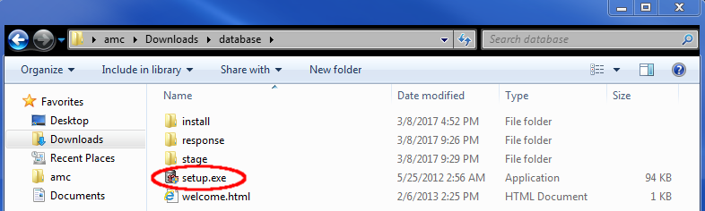

Once the Oracle DB installer starts up, you should see the introductory screen that follows:

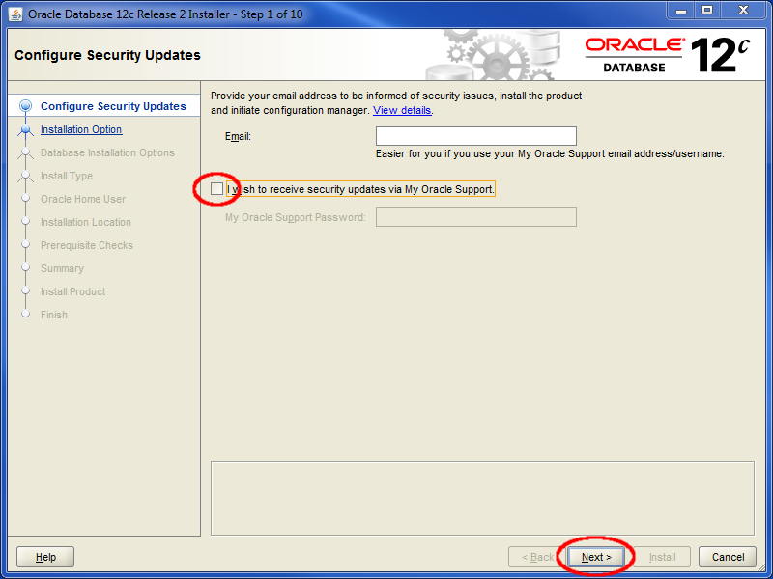

For the sake of an evaluation, you might consider unchecking the checkbox which asks if you’d like to receive security updates, especially if you don’t have a My Oracle Support account. In a production environment, obviously this decision may be quite the opposite.

Click Next to proceed. If you do not wish to receive updates, you’ll see the following window:

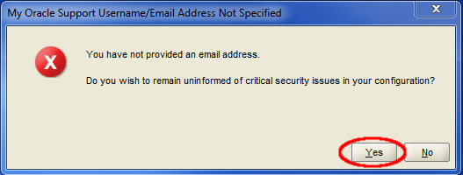

Click Yes to continue.

Step 2 – Select Installation Type. Select the **Create and configure a database** option.

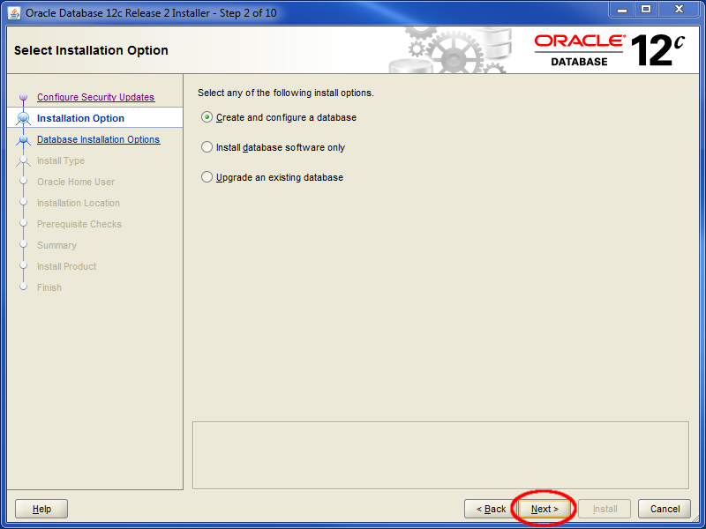

Click Next.

Step 3 – Select System Class.

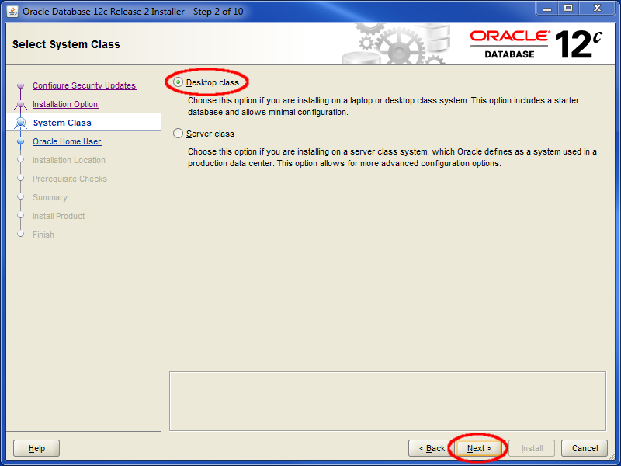

For the sake of evaluation, you can select *Desktop Class*. Again, in production you might consider the *Server Class* and all the advanced configuration options it might include. In the production scenario, you would likely enlist the aid of and Oracle DBA.

Click Next.

Step 4 – Specify Oracle Home User. For this instance, we’ll create a new Windows user named *oracle*. Select a password and remember it. In this example we’ll use the incredibly original and secure password of *oracle.*

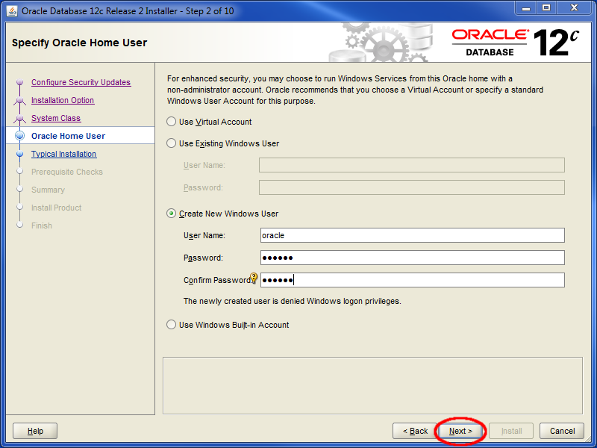

Click Next.

Step 5 – Typical Install Configuration.

Select an Oracle base directory location. The directory shown below: D:\Oracle is not the default. Choose an appropriate directory for your configuration.

You can leave the Global Database name as *orcl*. Enter (and remember!) a password for the *orcl* database name. Default password standards will not permit you enter *oracle* as a password. In this instance we choose the acceptable but insecure and unoriginal *Oracle123* as a password.

**Important:** For this install, make sure to **uncheck** the *Create as Container database* checkbox.

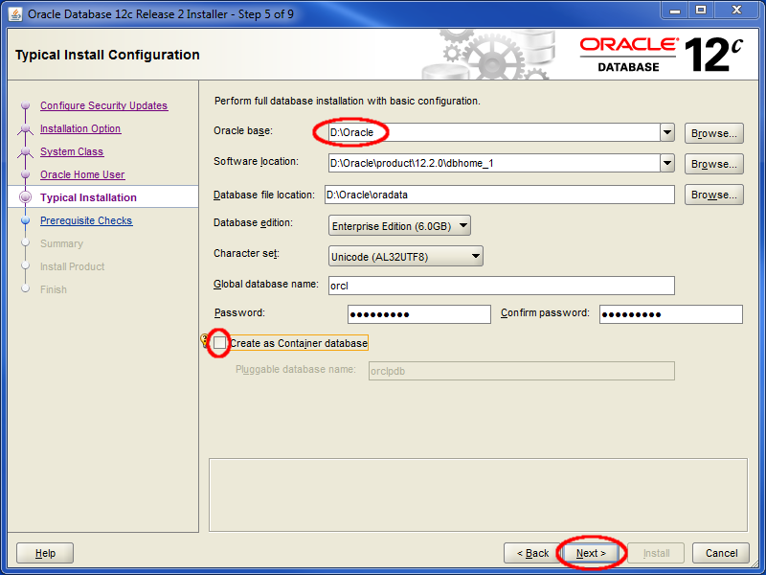

Click Next.

Step 6 – Prerequisite Checks.

You’ll see a window similar to the one that follows as it progresses through insuring that your system has the requisite components to properly install the Oracle DB. If requirements are not met, you will need to address those needs before you can proceed to the installation step.

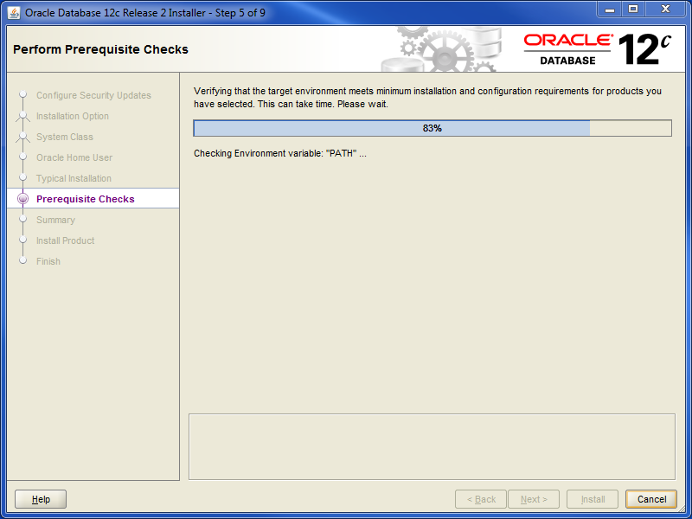

Step 7 - Summary. Once the Prerequisite checks complete successfully, you should see a window similar to the following:

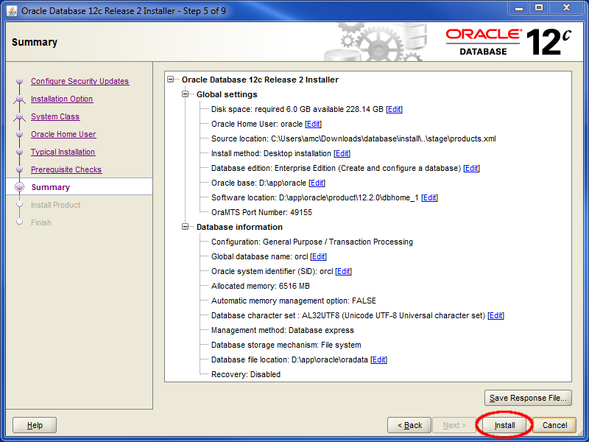

Click Install.

Step 8 – Install Product. As the install progresses you’ll see a window that looks similar to the following. Installation time will vary depending upon the processing speed of your system and your storage media type (i.e. solid state disks vs rotating disks). At minimum this should take a few minutes, in many cases much longer.

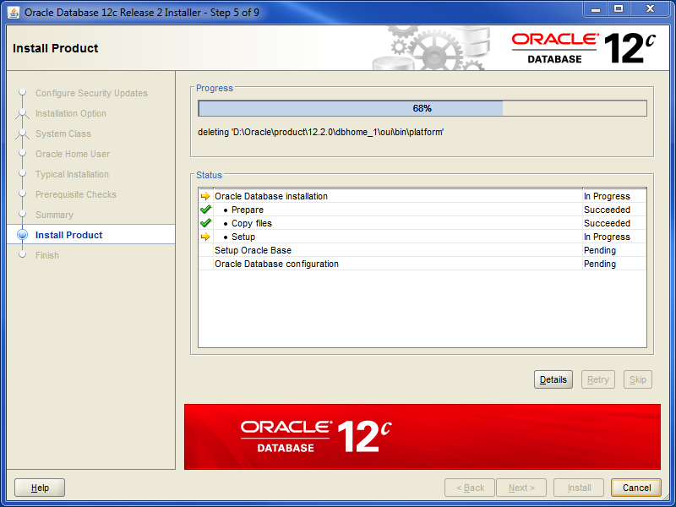

When the progress bar reaches 100%, your Install Product window should look like this:

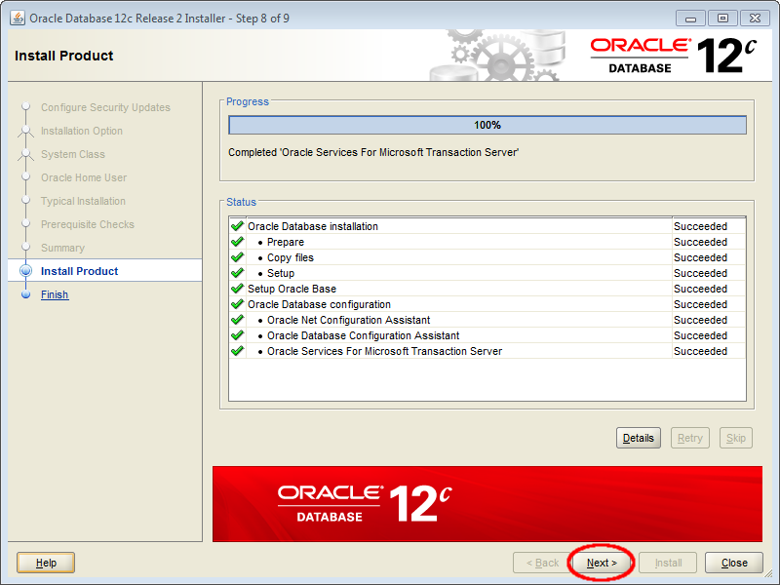

Click Next.

Step 9 – Finish. Once complete, the final window should look like this:

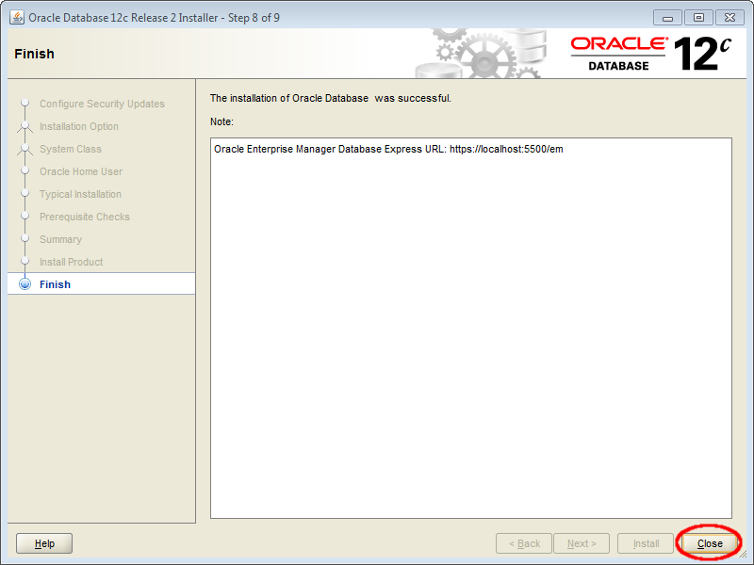

Click Close.

Continue on to the *Post-Install: Configuring Oracle DB for Advanced Management Console*sectionthat follows**.**

**Post-Install: Configuring Oracle DB for Advanced Management Console**

Reference: https://docs.oracle.com/javacomponents/advanced-management-console-2/install-guide/oracle-database-installation-and-configuration-advanced-management-console.htm#JSAMI182

1. As sysdba log into the SQL*Plus application to create the amc2 user and grant access to the database. Issue these SQL commands (a sample terminal session follows):

SQL> CREATE USER amc2 IDENTIFIED BY amc2

DEFAULT TABLESPACE users

QUOTA UNLIMITED ON users PASSWORD EXPIRE;

SQL> CREATE ROLE amc2_role;

SQL> GRANT CREATE SESSION, CREATE TABLE, CREATE SEQUENCE, CREATE VIEW, CREATE TRIGGER to amc2_role;

SQL> GRANT amc2_role TO amc2;

> **sqlplus sys as sysdba**

SQL*Plus: Release 12.2.0.1.0 Production on Tue Apr 3 12:00:06 2018

Copyright (c) 1982, 2016, Oracle. All rights reserved.

Enter password: ***Oracle123*** *(sample password, yours should be better)*

Connected to:

Oracle Database 12c Enterprise Edition Release 12.2.0.1.0 - 64bit Production

SQL> **CREATE USER amc2 IDENTIFIED BY amc2 DEFAULT TABLESPACE users QUOTA UNLIMITED ON users PASSWORD EXPIRE;**

User created.

SQL> **CREATE ROLE amc2_role;**

Role created.

SQL> **GRANT CREATE SESSION, CREATE TABLE, CREATE SEQUENCE, CREATE VIEW, CREATE TRIGGER to amc2_role;**

Grant succeeded.

SQL> **GRANT amc2_role TO amc2;**

Grant succeeded.

SQL> **exit**

Disconnected from Oracle Database 12c Enterprise Edition Release 12.2.0.1.0 - 64bit Production

2. Log back into SQL*Plus as user amc2. You will be prompted to set up a new password.

> **sqlplus amc2**

SQL*Plus: Release 12.2.0.1.0 Production on Tue Apr 3 12:20:36 2018

Copyright (c) 1982, 2016, Oracle. All rights reserved.

Enter password: **amc2**

ERROR:

ORA-28001: the password has expired

Changing password for amc2

New password: *choose a password here*

Retype new password:

Password changed

Connected to:

Oracle Database 12c Enterprise Edition Release 12.2.0.1.0 - 64bit Production

SQL> commit;

Commit complete.

SQL> **exit**

Disconnected from Oracle Database 12c Enterprise Edition Release 12.2.0.1.0 - 64bit Production**Install the Latest Java 8 Security Baseline Java Development Kit**

### A JDK, (not a JRE) is required for WebLogic.

### As of this document’s creation, the latest security baseline for Java 8 is JDK 8 update 191.

### IMPORTANT: With this revision of the document, the latest supported version of Fusion Middleware (WebLogic) is 12.2.1.3. There is a bug with 12.2.1.3 which fails to create an important configuration file called demoIdentity.jks (See My Oracle Support Doc ID 2357811.1 - FMW/WLS New Configuration with Latest JDK Failing to Start - ConfigException: Identity key store file not found: DemoIdentity.jks). There is a workaround; however, it is preferable (and easier) instead to install a version of Java earlier than Java 8u161/162 (i.e. Java 8u151/152) for WebLogic installation purposes. Once WebLogic installation is complete, the jdk8/ directory (referenced directly below) can be replaced with a more recent version.

### As an optional but recommended step, copy the contents of the installed JDK over to a local directory named jdk8. By using a local copy of the JDK and placing it in a generic directory name like jdk8, we will be able to replace WebLogic's JDK with a later Java 8 update at any time with no impact on the WebLogic install.

### In this document we will set the JAVA_HOME variable to C:\Oracle\jdk8 and copy the JDK contents to this directory.

### Install WebLogic 12.2.1.3

### For the release of Java Advanced Management Console 2.12, Oracle WebLogic 12.2.1.3 is the latest version and is supported but may not be listed in the documentation. *The installation steps and screenshots that follow demonstrate how to install WebLogic 12.2.1.3, Previous versions of WebLogic 12c are also supported for Java AMC 2.12. Installation of those versions should be quite similar.*

### Step 1 - WebLogic Install. Download the Oracle WebLogic Server 12.2.1.3 Generic installer from the Oracle website. The downloaded file should be named: fmw_12.2.1.3.0_wls_Disk1_1of1.zip

### Extracting the contents of the aforementioned zip file, there should be one file present: fmw_12.2.1.3.0_wls.jar

Begin the installation process by executing the following commands **as Administrator**. Your path may vary depending on installation location and JDK version installed.

>set JAVA_HOME=C:\Oracle\jdk8

>set PATH=%JAVA_HOME%\bin;%PATH%

>java -jar fmw_12.2.1.3.0_wls.jar

This will ultimately launch the universal installer as shown below.  
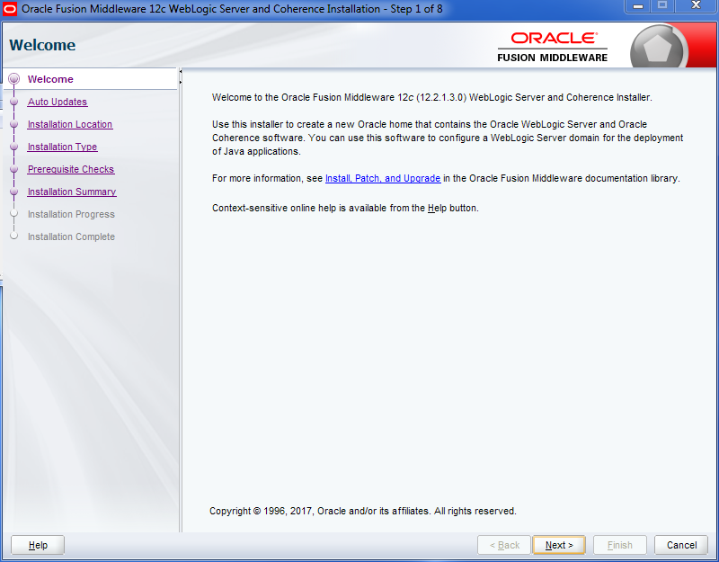

Click the Next Button

Step 2 - Auto Updates Screen. Leave screen as is and Skip Auto Updates.

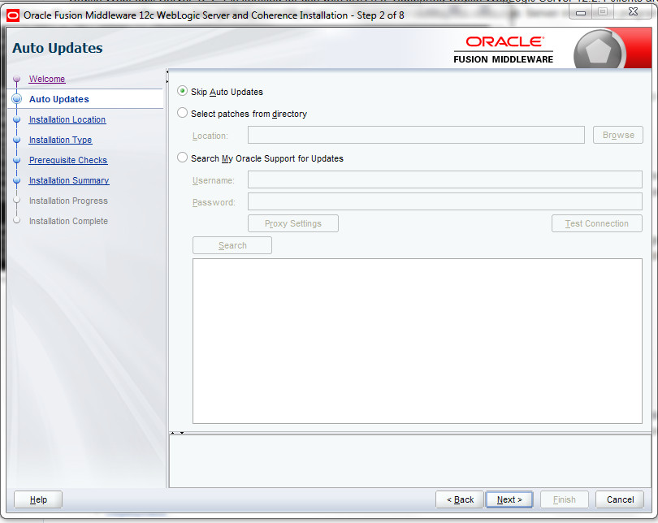

Click Next.

Step 3- WebLogic Install. Choose the installation directory. We'll stay with the default:

C:\Oracle\Middleware\Oracle_Home

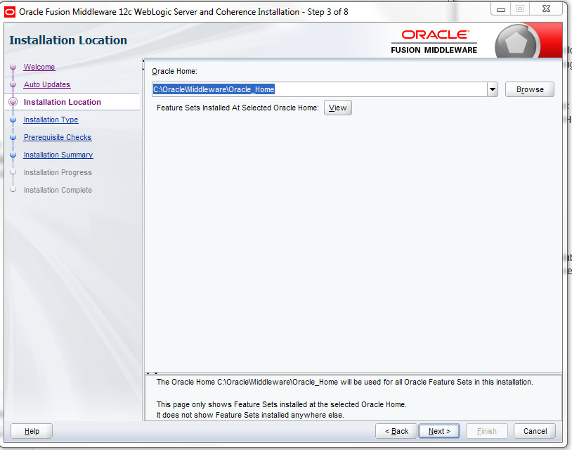  
  
Click the Next button.

Step 4 - WebLogic Install. The Installation Type should have only WebLogic server selected.

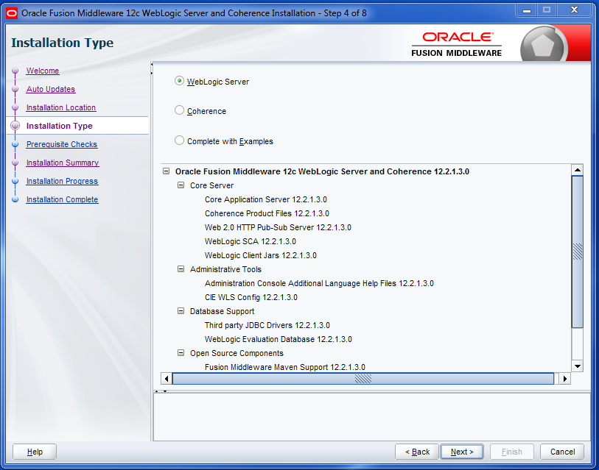

Click the Next button.

Step 5 - WebLogic Install. Prerequisite Checks: in order to continue, your JAVA_HOME variable should be set to a valid JDK, not a JRE.

If you're using a very recent version of Java 8, you might see a warning stating that at the time of the release of WebLogic 12.2.1.3, your version wasn't certified (because it didn't exist at the time of the release). You can ignore this warning.

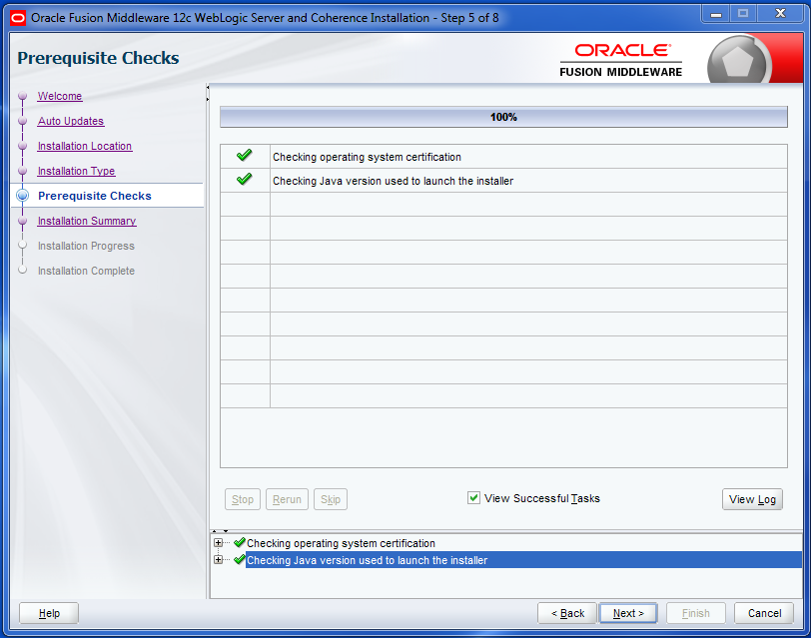

Click the Next button.

Step 6 - WebLogic Install. Installation Summary screen.

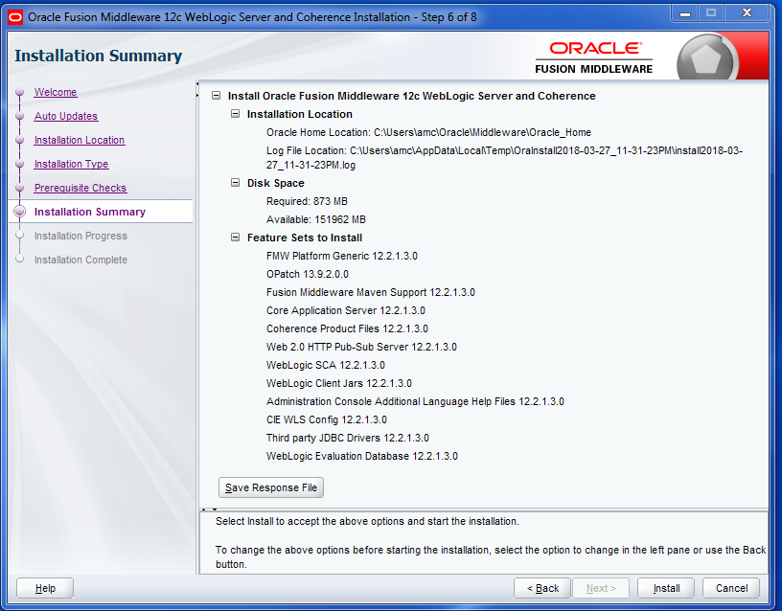

Click the Install button to begin installation.

Step 7 - WebLogic Install. Installation Progress screen. As the install progresses, green check marks will appear before completed items.

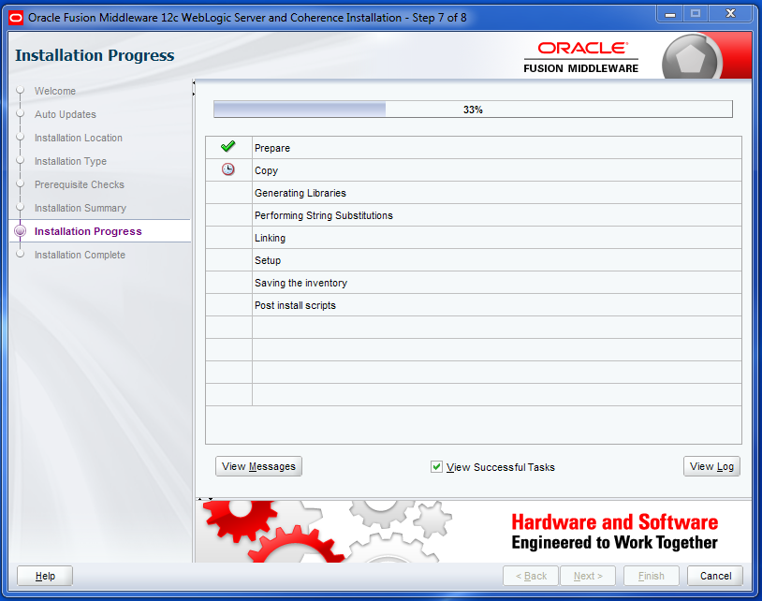

When all components have been successfully installed, the Next button at the bottom of the window will no longer be grayed out.

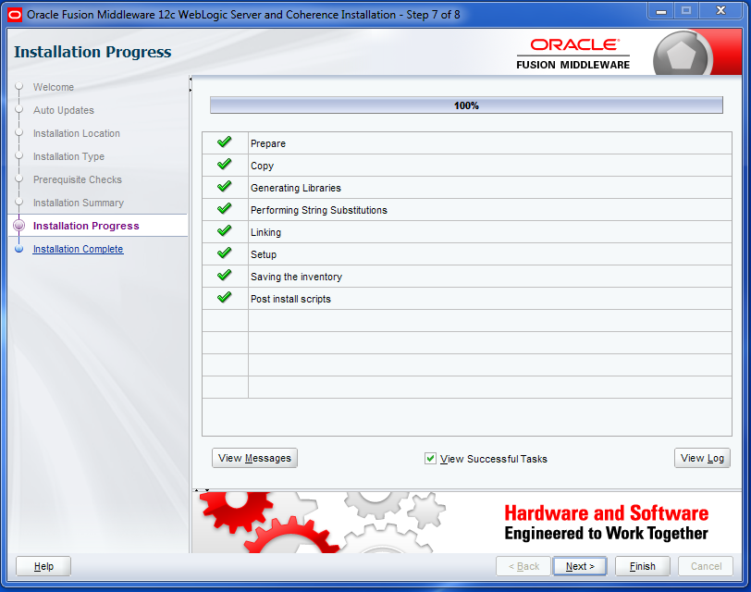

Click the Next button

Step 8 - WebLogic Install. Installation Compete screen.

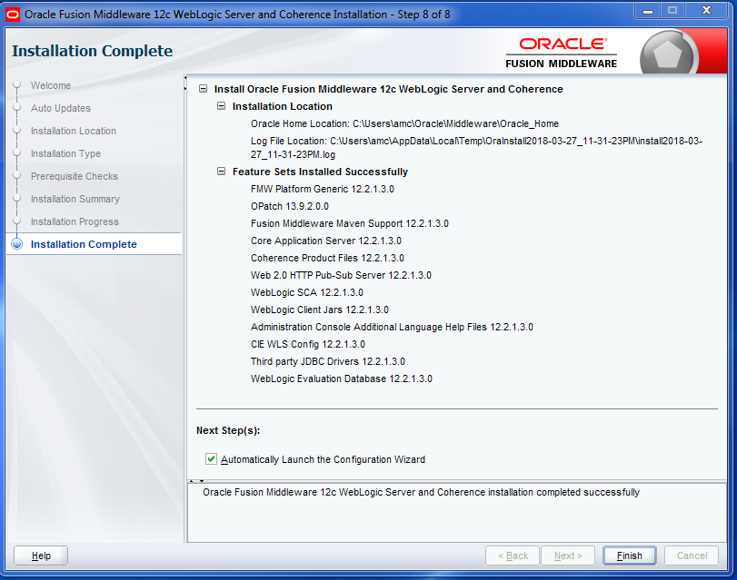

Click Finish.

**Fusion Middleware Configuration Wizard**

Once the WebLogic Installer completes, the Fusion Middleware Configuration Wizard will automatically start.

Step 1 - Fusion Middleware Configuration Wizard.Default setting should be to create a new domain, we'll leave the default settings as is. Note the file system location of the newly created domain.

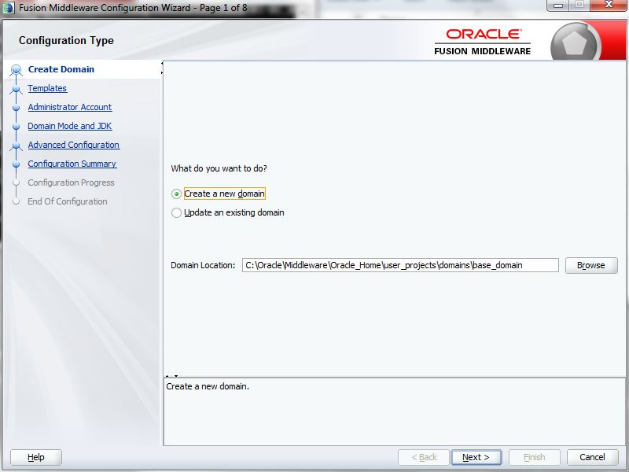

Click Next.

Step 2 - Fusion Middleware Configuration Wizard. We do not require any special templates for this install. By default the “Basic WebLogic Server Domain” templates are selected. Click on the “Include all selected templates” checkbox.

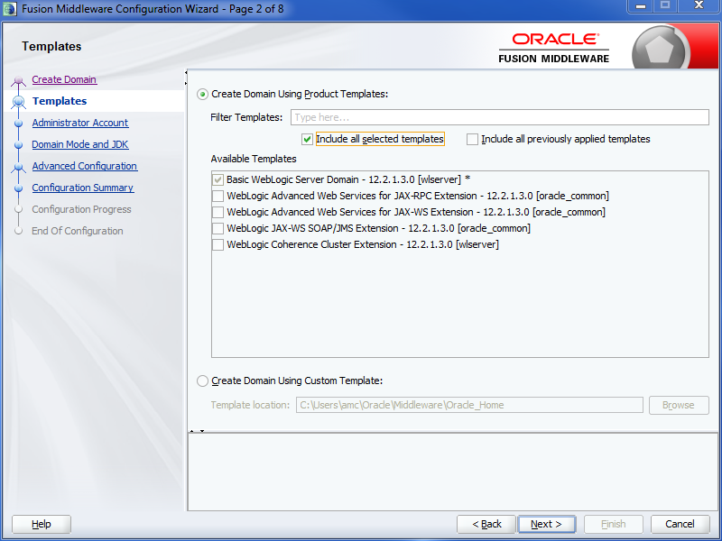

Click Next.

Step 3 - Fusion Middleware Configuration Wizard. Type in (and remember!) a WebLogic administrator password.

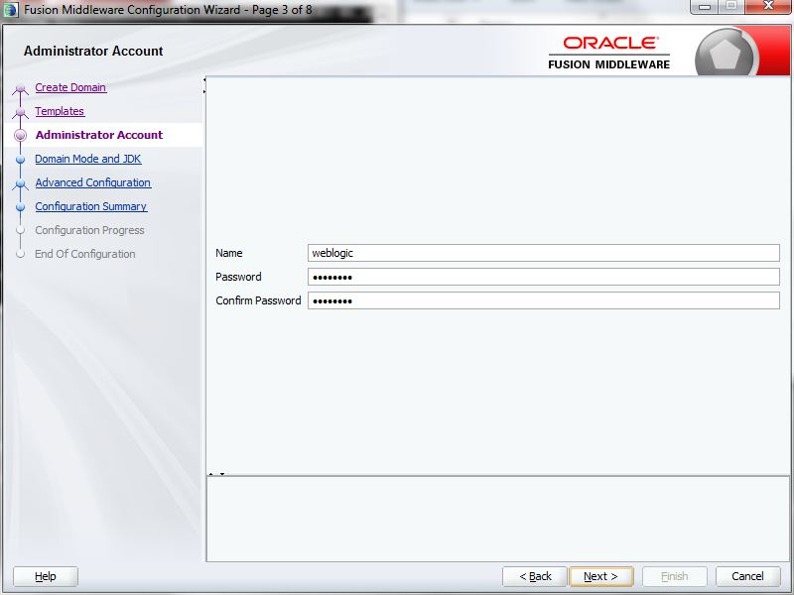

Click Next.

Step 4 - Fusion Middleware Configuration Wizard. For a prototype installation, "Development" Domain Mode is appropriate.

Because we installed a local copy of the JDK and set the JAVA_HOME variable prior to installation, the JDK location specified in the JDK section should point to the local copy, in our case C:\Oracle\jdk8.

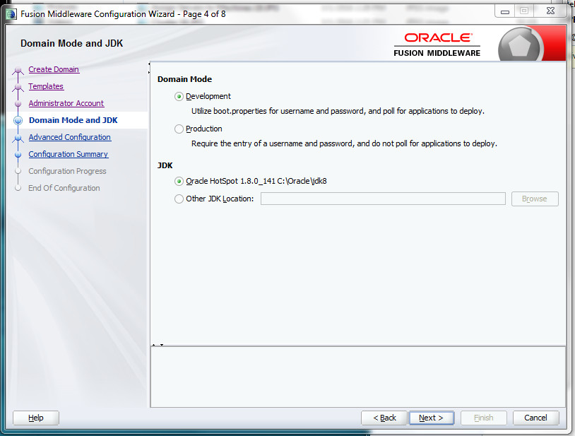

Click Next.

Step 5 - Fusion Middleware Configuration Wizard. For this screen, **check all three checkboxes**, so we can better understand the installation and fine tune our configuration.

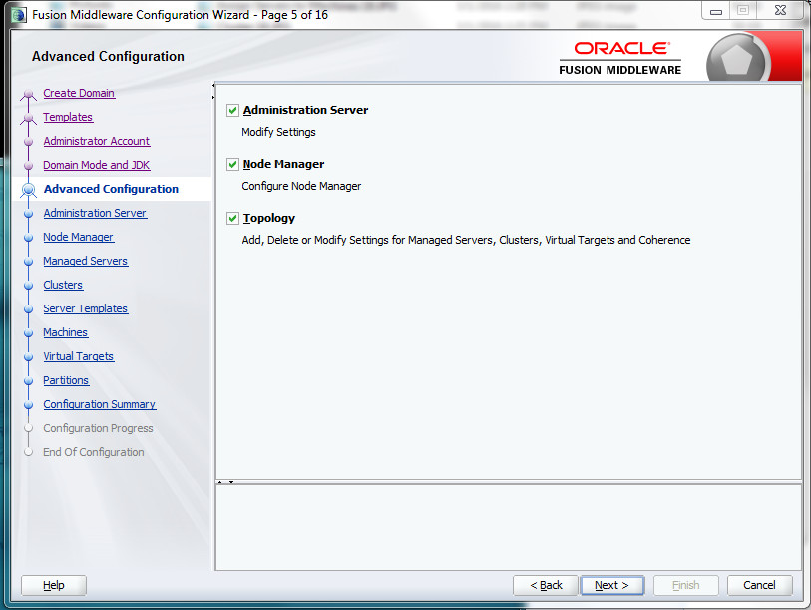

Click Next.

Step 6 - Fusion Middleware Configuration Wizard. Because we chose to configure the Administration Server in the last step, we can further refine the AdminServer's Listen Address. It is important to understand at which IP + TCP port the AdminServer will run.

WebLogic will by default pickup all available interfaces (which can be determined by issuing the “ipconfig /all” command). This can be very problematic on Windows with its default “Turedo Tunneling Pseudo-Interface” which uses IPv6. When Windows is not well configured for IPv6, WebLogic performance will suffer because the java process will use the unconfigured IPv6 first, before it times out, and then IPv4.

**In short, it is a good idea to explicitly define the IPv4 address you want to use, instead of**

**giving all interfaces to the WebLogic java processes.**

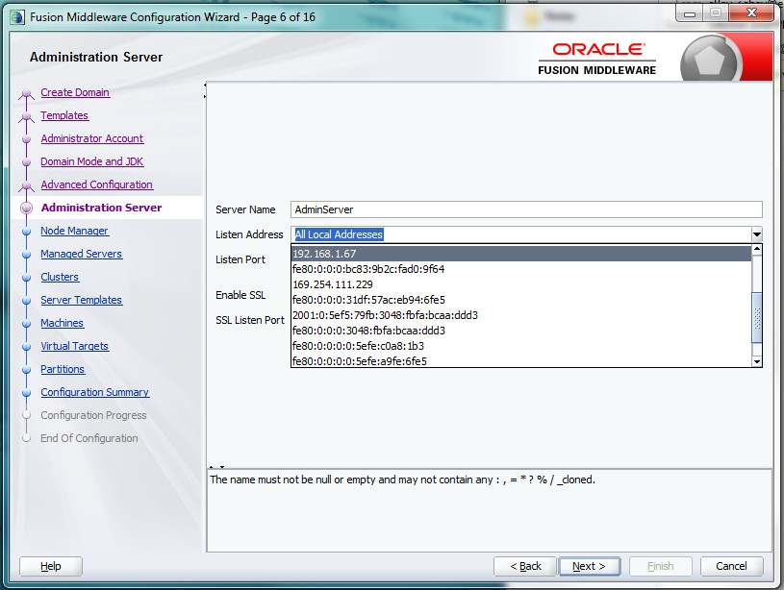

Once you select the appropriate IPv4 address from the "Listen Address" pull-down menu, leave the Listen Port at 7001 and the SSL information blank.

After Installation, we'll use the selected IP Address above to open the WebLogic Admin Console, for example, http://192.168.1.67:7001/console

Click Next.

Step 7 - Fusion Middleware Configuration Wizard. Configure the “Per Domain Nodemanager” and define the (Embedded LDAP)NodeManager credentials.

On Production Systems the NodeManager is started as a System Service

and is used to start and stop the AdminServer, clusters and Managed Servers.

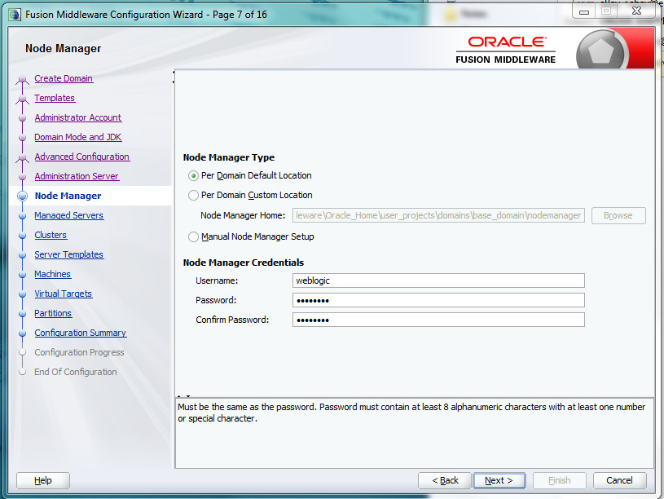

Once a username and password have been entered and confirmed (and remembered!), click Next.

Step 8 - Fusion Middleware Configuration Wizard. On this screen click on the "+ Add" button to add a Managed Server. **Rename the Managed Server to "AMC-Server"** and click on the **Listen Address pull-down menu to select the IPv4 Address chosen in Step 6**. **Change the Listen port to 8007** (so as not to interfere with the AdminConsole), **click on the Enable SSL checkbox** and **change the SSL Listen Port to 8008.**

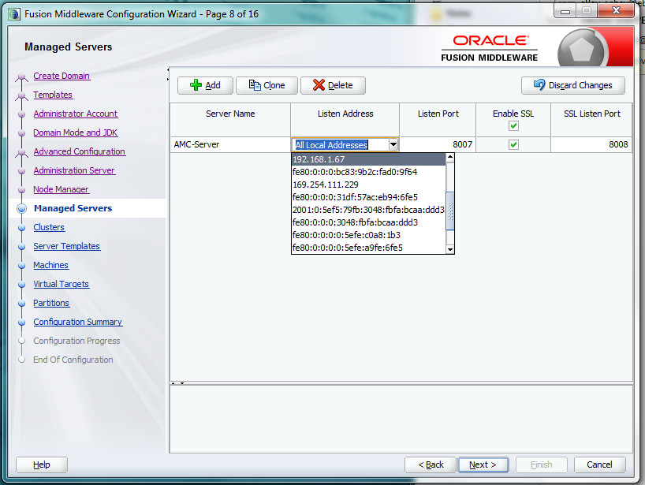

Click Next.

Step 9 - Fusion Middleware Configuration Wizard. We won't configure any clusters, so you can skip this screen.

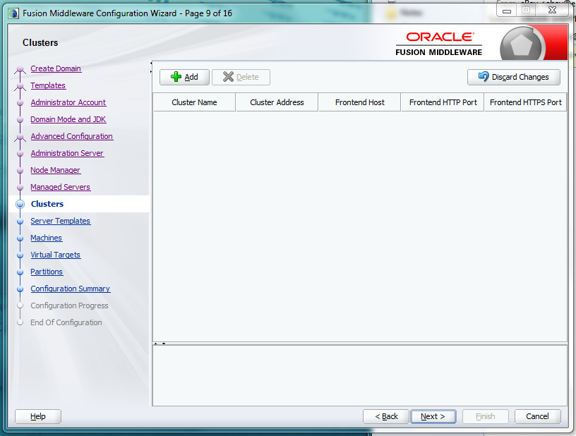

Click Next.

Step 10 – Server Templates. We won't configure any server templates, so you can skip this screen.

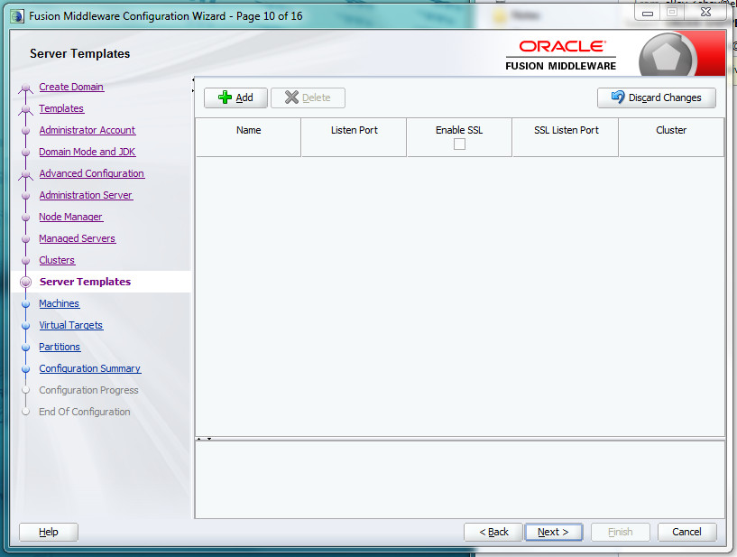

Click Next.

Step 11 - Fusion Middleware Configuration Wizard. Click on the “Add” button and **name the Machine Name to "AMC-Machine"** and click on the **Listen Address pull-down menu to select the IPv4 Address chosen in Step 6**. **Leave the Node Manager Listen port at 5556.**

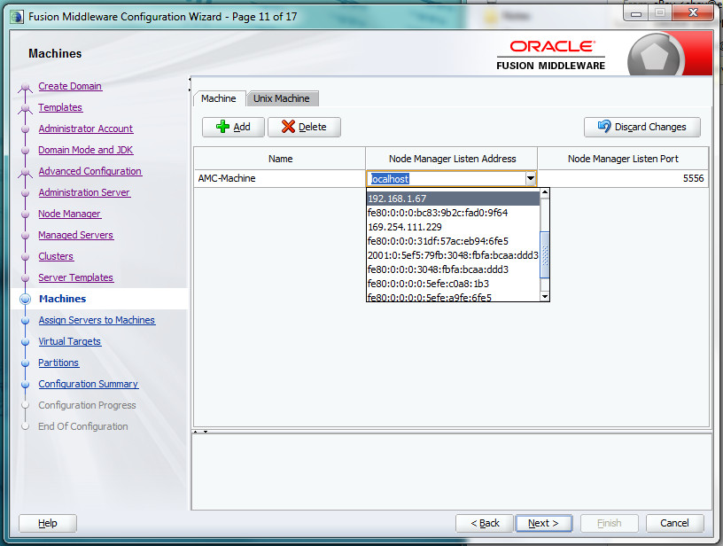

Click Next.

Step 12 - Fusion Middleware Configuration Wizard. Assign all WebLogic Servers (java processes) that you want to manage with the NodeManager. In this case **we include AMC-Server and AdminServer under AMC-Machine.**

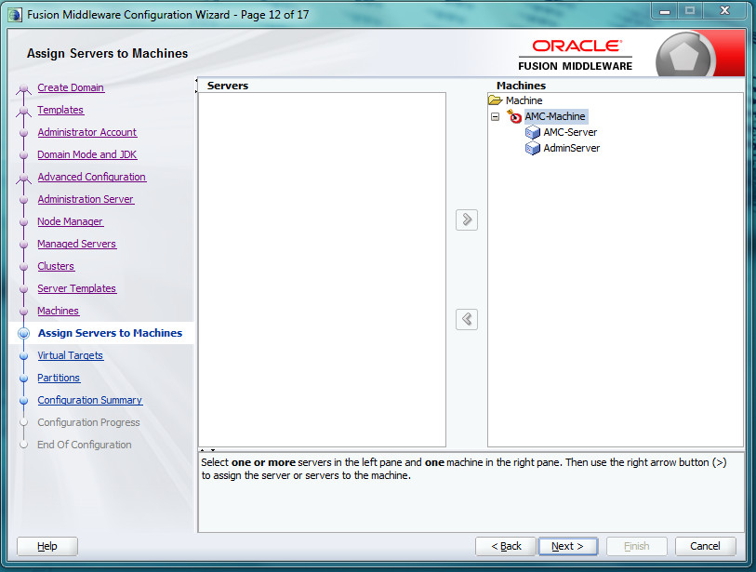

Click Next.

Step 13 – Virtual Targets. We won't configure any virtual targets, so you can skip this screen.

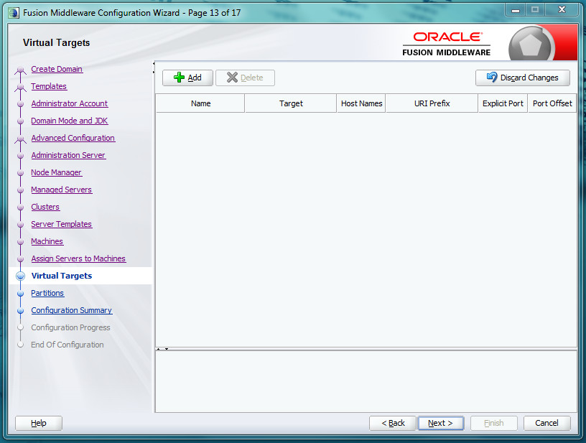

Click Next.

Step 14 – Partitions. We won't configure any partitions, so you can skip this screen.

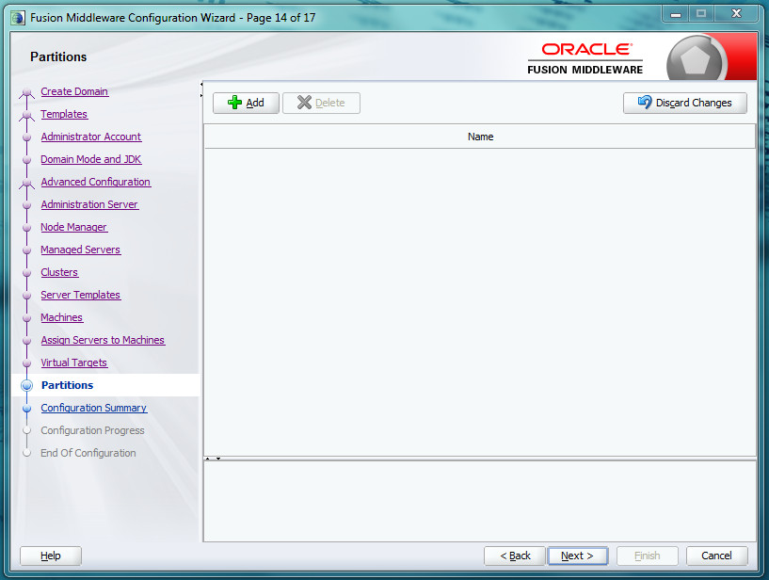

Click Next.

Step 15 - Fusion Middleware Configuration Wizard. Configuration Summary.

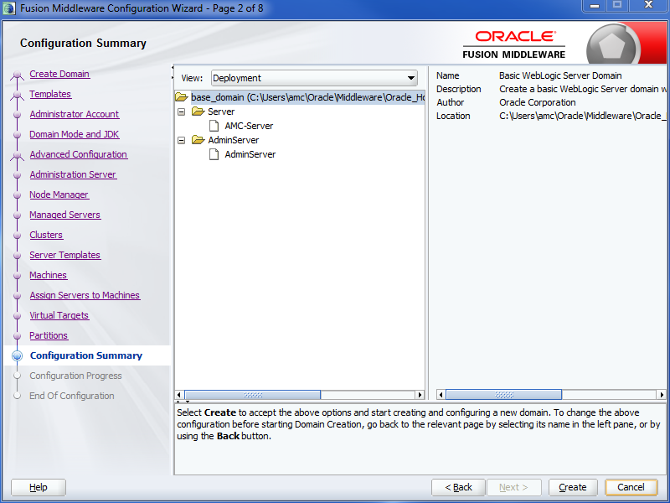

Click Create.

Step 16 - Fusion Middleware Configuration Wizard. Configuration Progress. When complete, the Next button will no longer be grayed out.

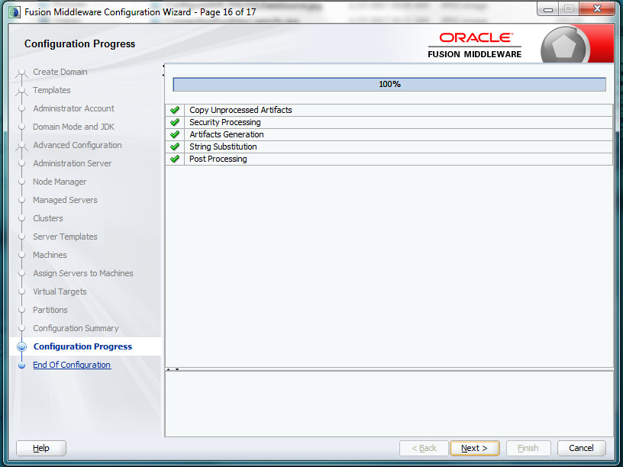

Click Next.

Step 17 - Fusion Middleware Configuration Wizard. Configuration Success.

Remember the domain location and Admin Server URL for future reference.

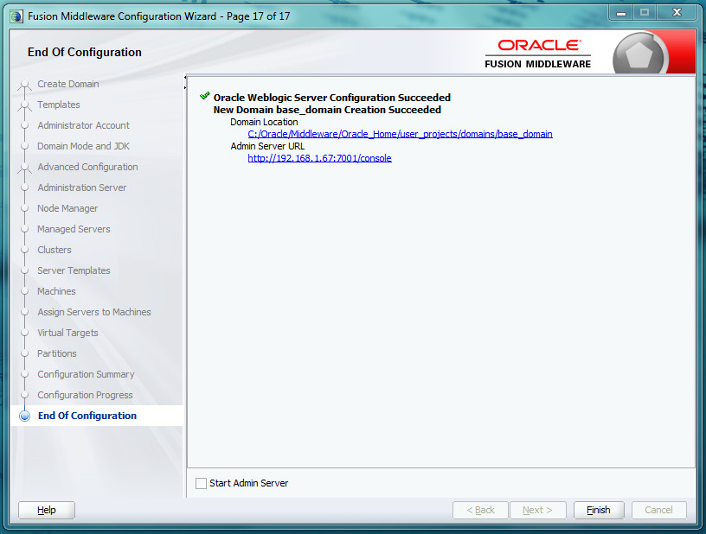

On the bottom of the screen, you can optionally check the *Start Admin Server* checkbox to start the Admin Server now, or you can continue to the *Install Windows Services for WebLogic, Node Manager, and the Java AMC Server Application* section to have the system automatically start the necessary WebLogic components at boot time.

Click Finish.

**Install an identity certificate (optional for Java AMC Evaluation)**

WebLogic will create and utilize a self-signed identity certificate which may not be adequate for certain browser deployments. In this situation, it might be necessary to configure WebLogic to use a custom keystore containing an identity certificate from a trusted authority.

Assumption: The custom keystore containing the necessary certificate(s) is provided as a file in ***JKS*** format. For a little more information on installing trusted certificates into a Java keystore, check out:

https://blogs.oracle.com/jtc/entry/installing_trusted_certificates_into_a

1. If you don't know it already, determine the *alias name* of your trusted certificate. You can use the keytool utility to find out. Here's an example invocation assuming the certificate keystore can be found in a file named identity.jks:

>C:\Oracle\jdk8\bin\keytool.exe -keystore identity.jks -list -v

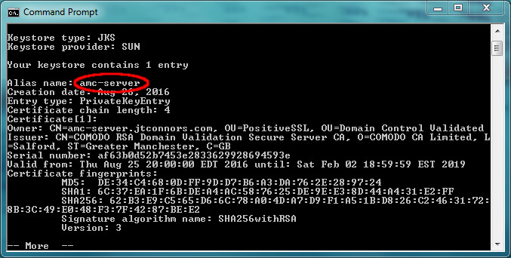

2. It is important to validate your identity keystore certificate chain. WebLogic can be finicky when it comes to insuring that the provided private key along with the root CA and any intermediate certificates (referred to as a certificate chain) are valid and stored in the correct order.

WebLogic contains a ValidateCertChain program as part of the distribution which can be used to validate the keystore. It can be run like this:

>java -cp C:\Oracle\Middleware\Oracle_Home\wlserver\server\lib\weblogic.jar utils.ValidateCertChain -jks amc-server identity.jks

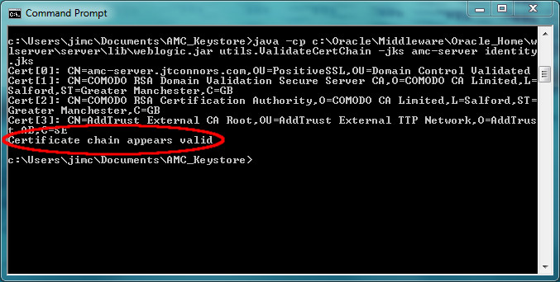

3. If it isn't running already, start the WebLogic server. It can be started manually with the following commands:

> C:\Oracle\Middleware\Oracle_Home\user_projects\domains\base_domain\bin\startWebLogic.cmd

4. Log into the WebLogic Console:

http://*<IP Address>:*7001/console

Username: *<WebLogic admin user>*

Password: *<WebLogic admin password>*

5. Instruct WebLogic use a different Identity KeyStore.

a. Within the WebLogic console, from the domain structure block to the left, go to Environment and select Servers

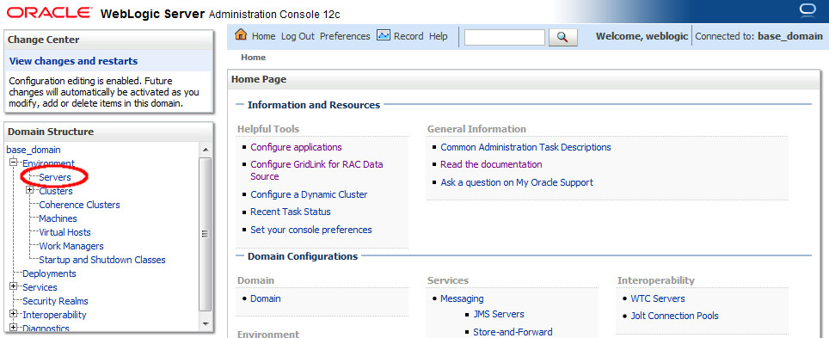

b. Click on AMC-Server link under Servers table

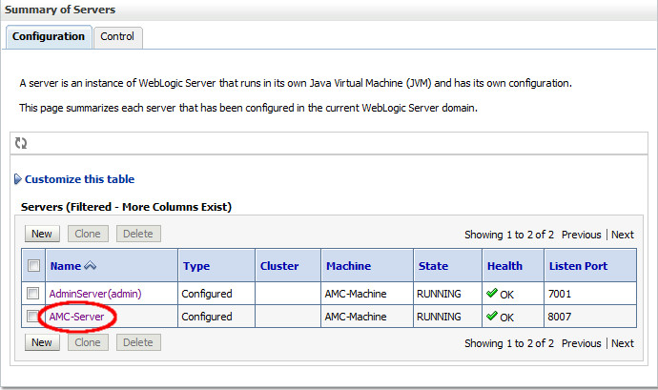

c. Click on Keystores tab

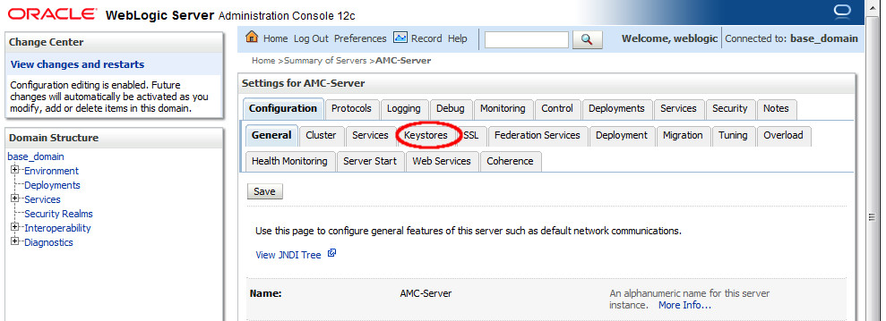

d. For the "Keystores:" entry, click "Change" button

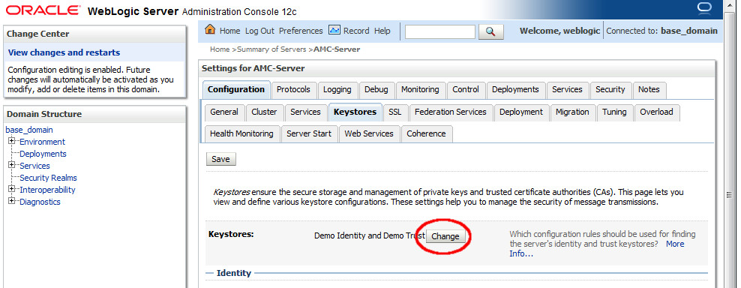

e. Select Custom Identity and Java Standard Trust

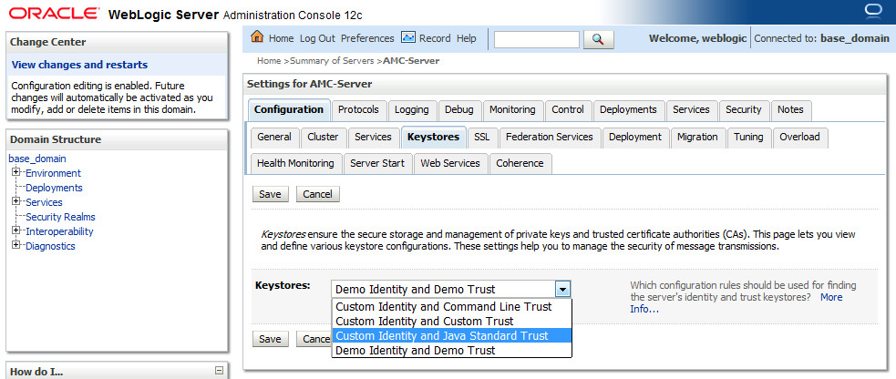

f. Click Save

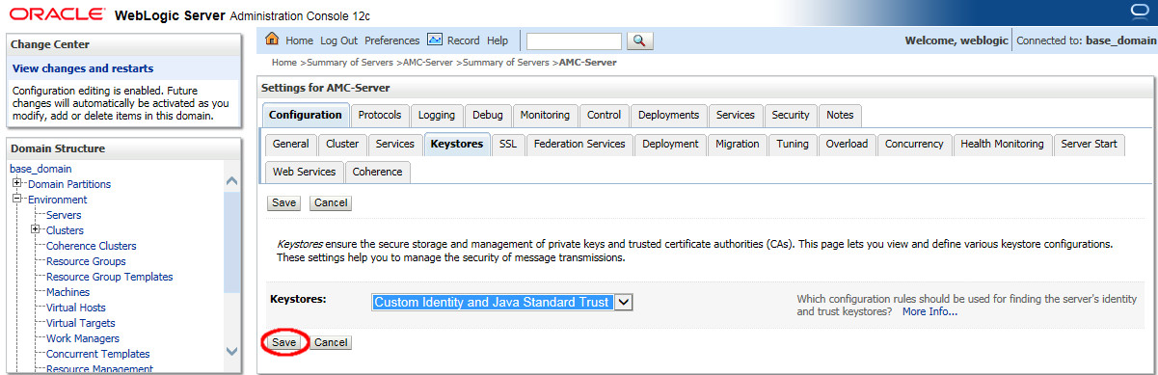

6. Specify Custom Identity Keystore information

1. Under the same "Keystores" tab as in the previous step, Fill in the location of your custom identity keystore.
2. Custom Identity Keystore Type is: jks
3. Fill in Custom Identity Keystore Passphrase.
4. Fill in the Confirm Custom Identity Keystore Passphrase textfield with the same passphrase entered in the previous step.
5. Java Standard Trust Keystore should point to the JDK's cacerts file
6. Example: C:\Users\amc\jdk8\jre\lib\security\cacerts
7. Java Standard Trust Keystore Type should be: jks
8. Unless it's been changed, the Java Standard Trust Keystore Passphrase should be *changeit*
9. Fill in the Confirm Java Standard Trust Keystore Passphrase text field with the same passphrase entered in the previous step.
10. Click Save

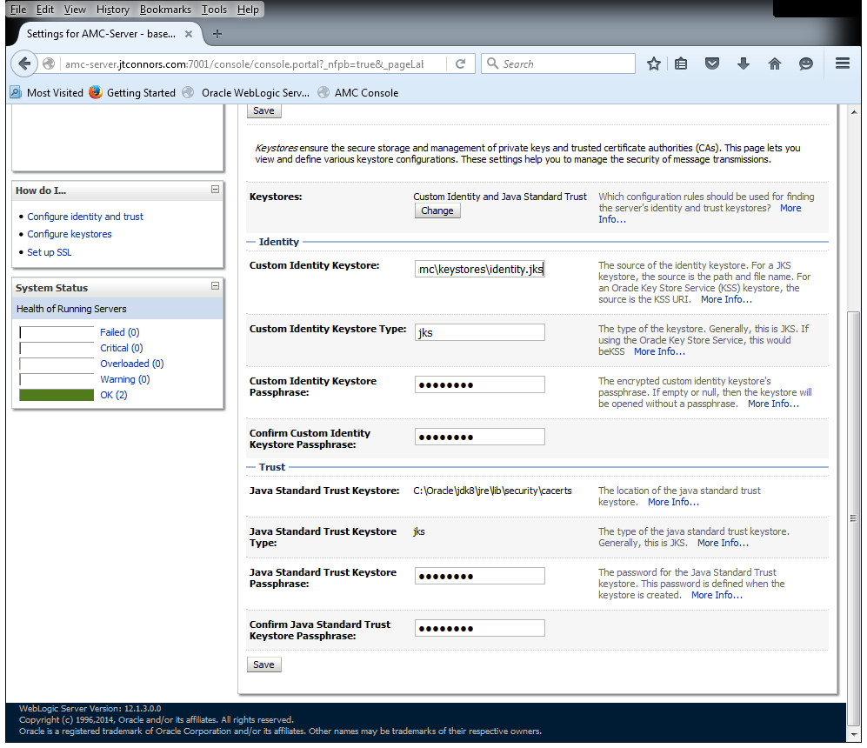

7. Configure SSL

a. Within the WebLogic console, from the domain structure block to the left, go to Environment and select Servers

b. Click on AMC-Server link under Servers table

c. Click on the SSL tab

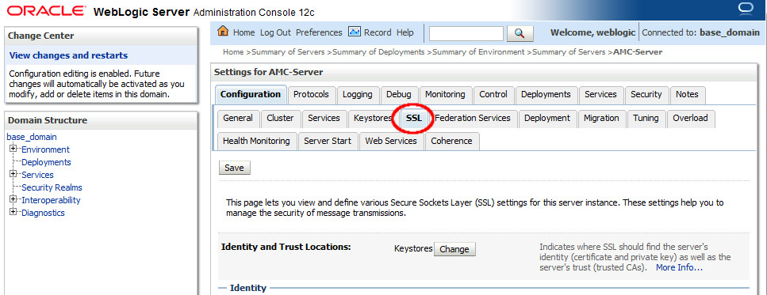

d. Enter the Private Key Alias. This was determined in Step 1.

Example: amc-server

e. Enter your Private Key Passphrase.

f. Fill in the Confirm Private Key Passphrase text field with the same passphrase entered in the previous step.

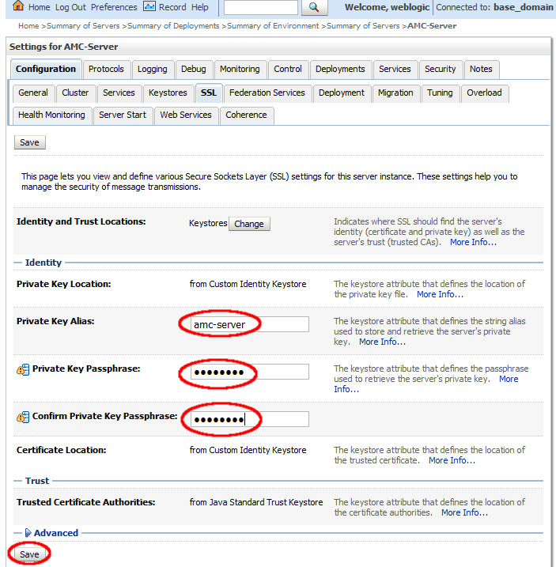

g. Click Save

**Additional WebLogic Configuration for Java Advanced Management Console**

**Run the Java Version of NodeManager**

WebLogic can be configured to run the NodeManager process natively or in Java. For Java AMC, we want to run the Java version of NodeManager. In order to effect this change, we need to modify nodemanager.properties file.

This file is located in the %DOMAIN_HOME%\nodemanager\ directory. In our example, that would be

c:\Oracle\Middleware\Oracle_Home\user_projects\domains\base_domain\nodemanager\nodemanager.properties

Edit the file and change the NativeVersionEnabled flag to false.

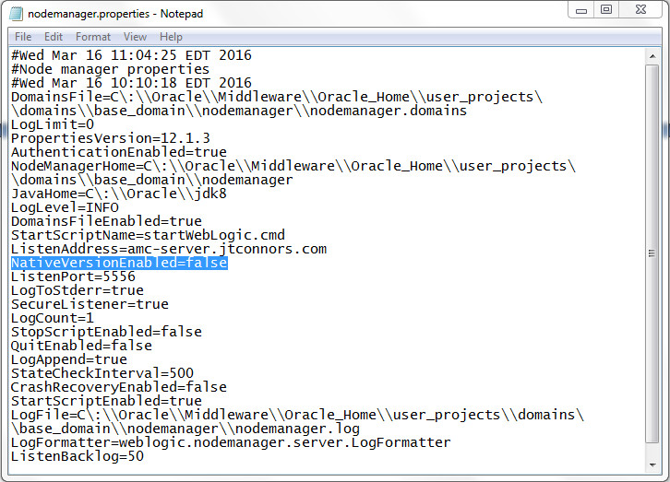

**Increase the JTA Timeout Parameter**

Errors in the WebLogic Server may occur if the JTA transaction timeout is not set to a long enough value for database access.

(<http://docs.oracle.com/javacomponents/advanced-management-console-2/install-guide/wlssetup.htm#A1147784>)

A. If it isn't running already, start the WebLogic server. It can be started manually with the following commands:

>C:\Oracle\Middleware\Oracle_Home\user_projects\domains\base_domain\bin\startWebLogic.cmd

B. Log into the WebLogic Console:

http://*<IP Address>:*7001/console

Username: *<WebLogic admin user>*

Password: *<WebLogic admin password>*

C. From the Domain Structure block in the left panel, navigate to Services and select JTA from services.

D. Select the Configurations tab and then click the JTA sub tab.

E. On the Java Transaction API (JTA) page, enter the Timeout Seconds value as 300.

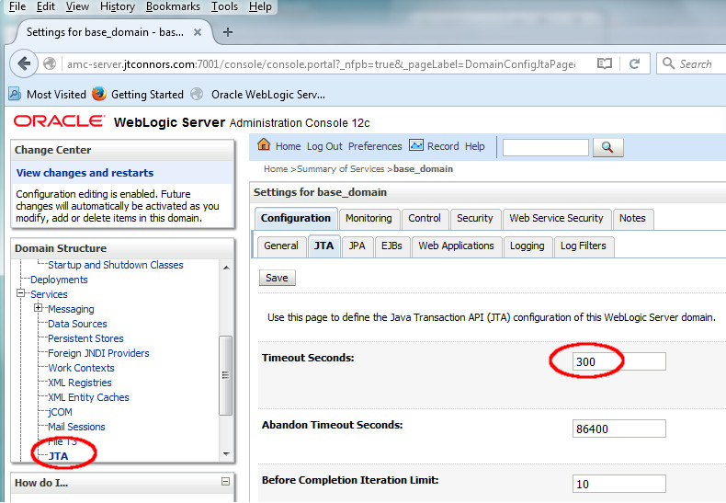

F. Click Save

**Install Windows Services for WebLogic, Node Manager, and the Java AMC Server Application**

The WebLogic component of Java Advanced Management Console is comprised of three separate processes. In order to enable the proper and automatic start up sequence at boot time, these processes should be converted into Windows services. This guide provides two options to create these services:

1. Create the services using an automated script. This is the easier method and is described directly below.
2. Manually Create the WebLogic Services. This method goes into more detail and potentially offers more flexibility in the creation of the Windows services. These instructions can be found in the Appendix section under Manually Installing Windows Services for WebLogic, Node Manager and the Java AMC Application

The following steps will create three Windows services that will enable WebLogic, the WebLogic Node Manager and the Java AMC application to automatically start up at boot time.

1. Create and populate a scripts directory. One recommendation is to place scripts directly under the master directory where all WebLogic software would be housed. For example:

>mkdir C:\Oracle\scripts

>cd C:\Oracle\scripts

2. Place the three provided script files: svcsetup.cmd , makeAllScripts.bat and makeAllScripts.ps1 into the scripts directory created in the previous step. Assuming C:\Oracle\scripts is our scripts location, it should look as follows:

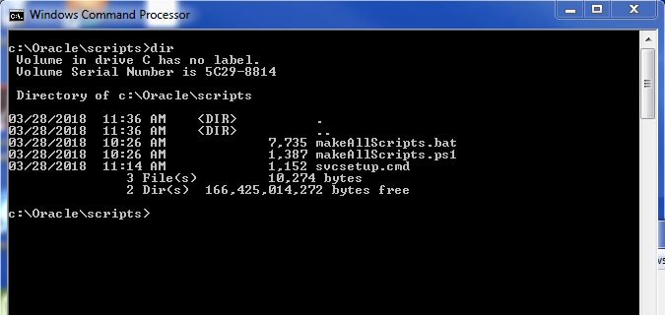

3. Examine and edit, if necessary, the svcsetup.cmd file in the scripts/ directory.

3a. Check to see if the AMC_HOME variable is set correctly. The WebLogic Middleware/ directory should reside directly under the directory specified by AMC_HOME. If your directory differs from the default value of AMC_HOME (C:\Oracle), it is important that you edit the AMC_HOME to match your installation directory.

REM

REM AMC_HOME must point to the AMC Master directory from which all WebLogic

REM software is installed.

REM

set AMC_HOME=C:\Oracle

3b. Following AMC_HOME, make sure the JAVA_HOME variable points to the location of your JDK.

REM

REM JAVA_HOME location is better off having a directory name like "jdk8" as

REM opposed to a specific version (like "jdk1.8.0_161), so that it can easily

REM be replaced with a newer update, keeping the generic "jdk8" name.

REM For organization's sake, it might make sense to have a jdk directly under

REM the AMC_HOME directory.

REM

set JAVA_HOME=%AMC_HOME%\jdk8

3c. Optional: Uncomment out the following JAVA_OPTIONS setting if you suspect IPv4/IPv6 networking conflicts. It might be best to leave this as is until suspicions of network irregularities arise.

REM

REM This option has been handy in the past where the WebLogic server had

REM multiple network interfaces with both IPv4 and Ipv6 stacks. In the case

REM where network irregularities take place, try uncommenting the

REM JAVA_OPTIONS line that follows.

REM

REM set JAVA_OPTIONS=-Djava.net.preferIPv4Stack=true

3d. The remainder of the svcsetup.cmd should be left as is unless some specific customization is required.

REM

REM These Variables are set relative to AMC_Home and in most cases should be

REM left alone

REM

set MW_HOME=%AMC_HOME%\Middleware\Oracle_Home

set WL_HOME=%MW_HOME%\wlserver

set DOMAIN_NAME=base_domain

set DOMAIN_HOME=%MW_HOME%\user_projects\domains\%DOMAIN_NAME%

set USERDOMAIN_HOME=%DOMAIN_HOME%

4. Run the makeAllScripts.bat command. It will prompt you to provide input for the following values:

* The Java Advanced Management Console *server instance name*. The default value is **AMC-Server**, and unless, during the WebLogic install you specified a different name, this should not be changed.
* The WebLogic admin *user name*. The default value is **weblogic**. If you followed the install instructions in this document, this value should not be changed either.
* The WebLogic admin *password*. The default value is **weblogic1**, which is likely different from the one you chose during the installation phase. Use the value you used (and hopefully remembered!) during the WebLogic install.
* The *hostname or IP address* of your WebLogic server.
* The port number of the WebLogic Administration Server. The default value is **7001**, and unless you specified something different during the WebLogic install, this should not be changed.

Here’s what a sample invocation of the script looks like. In this instance, the defaults were chosen for the AMC-Server, WebLogic admin user name and the WebLogic administration server port number values. The selected WebLogic password was changed to AMC2Demo, and the hostname of the WebLogic Server was set to an example fully qualified domain name. Yours will certainly be different.

C:\Oracle\scripts>makeAllScripts.bat

Checking file locations

1 file(s) copied.

Editing scripts in C:\Oracle\Middleware\Oracle_Home\wlserver\server\bin

Press any key to continue . . .

Found existing scripts directory: C:\Oracle\scripts.

Type a new server name or press enter to accept: [AMC-Server]

Type a new user name or press enter to accept: [weblogic]

Type a new password or press enter to accept: [weblogic1]**AMC2demo**

Enter the correct hostname or IP Address: **amc-server.jtconnors.com**

Type a new port number or press enter to accept: [7001] :

You've chosen to set

the Admin Server name to: AMC-Server

the username to: weblogic

the password to: AMC2demo

the hostname/IP to: amc-server.jtconnors.com

and the port to: 7001

are these values correct? [Y/n]Y

Created installAMCServerSvc.cmd in C:\Oracle\scripts

set MAX_CONNECT_RETRIES=

Created installWebLogicSvc.cmd in C:\Oracle\scripts

Created installNodeMgrSvc.cmd in C:\Oracle\scripts

Created uninstallAMCServerSvc.cmd in C:\Oracle\scripts

Created uninstallWebLogicSvc.cmd in C:\Oracle\scripts

Created uninstallNodeMgrSvc.cmd in C:\Oracle\scripts

Finished

5. With this step complete, a total of 6 cmd files have been created. Three are used to install the WebLogic Windows Services:

installWebLogicSvc.cmd

installNodeMgrSvc.cmd

installAMCServerSvc.cmd

and three corresponding cmd files are used to uninstall these services if the need arises.

uninstallWebLogicSvc.cmd

uninstallNodeMgrSvc.cmd

uninstallAMCServerSvc.cmd

Run the following commands **as Administrator** in the order below:

> installWebLogicSvc.cmd

> installNodeMgrSvc.cmd

> installAMCServerSvc.cmd

6. Once these services have been installed, they will automatically be started at next reboot. To avoid rebooting, you can start those services from the Windows Services Manager by executing the following command **as Administrator** from a Windows cmd shell:

> services.msc

This will bring up the window that follows. Scroll down to the bottom and search for the “wlsvc base_domain_AMC-Server” service. Select that service and click on the “Start” link:

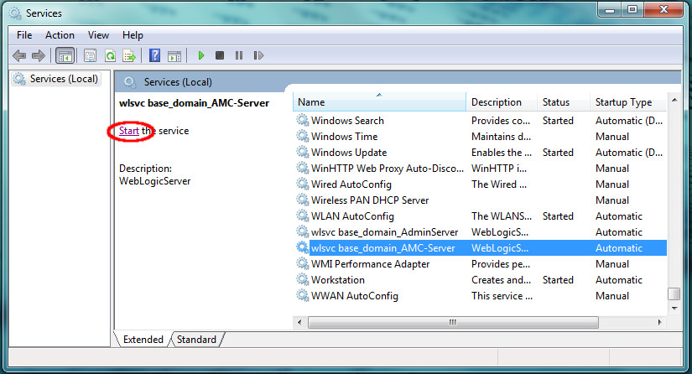

Because these services were configured with dependencies, all three services should start when the *AMC-Server* service is selected to start because of the following dependencies:

*AMC-Server*

wlsvc base_domain_AMC-Server

depends on

*Node Manager*

*Oracle Weblogic base_domain NodeManager (C_Oracle_MIDDLE~1_ORACLE~1_wlserver)*

depends on

*AdminServer*

wlsvc base_domain_AdminServer

In the case where AMC-Server is selected to start, it will wait till its dependency (Node Manager) starts. And Node Manager won’t start until its dependency (AdminServer) starts. (Likewise, if you choose to stop the “wlsvc base_domain_AdminServer” service, it works backwards, i.e. it will automatically stop the other two dependent Windows services.)

**Configure WebLogic Server with Oracle DB**

As taken (with some modifications) from <http://docs.oracle.com/javacomponents/advanced-management-console-2/install-guide/wlssetup.htm>

and

https://docs.oracle.com/javacomponents/advanced-management-console-2/install-guide/oracle-database-installation-and-configuration-advanced-management-console.htm

The default Oracle DB listener configuration will likely need to be modified in order to properly communicate with the recently installed WebLogic Server. Specifically, the Oracle DB listener service must be configured to listen at a specific port (1521) and IP address (or hostname) that you provide.

**Option 1: Configure Oracle DB Listener Service (Oracle DB and WebLogic co-resident on same server)**

1. Stop the Oracle LSNRCTL service **as Administrator**:

> LSNRCTL stop

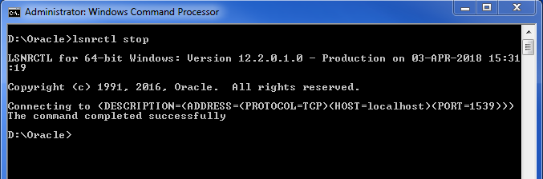

2. Copy the following files for safe keeping:

%ORACLE_HOME%\network\admin\listener.ora

%ORACLE_HOME%\network\admin\tnsnames.ora

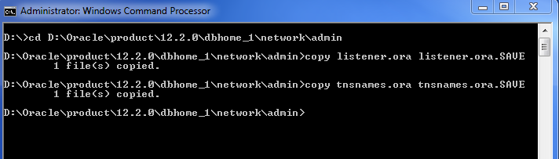

3. Edit %ORACLE_HOME%\network\admin\listener.ora to look as follows, replacing the your host_name string with either your Oracle DB server’s IP address or hostname. As this file indicates, the listener will be configured on port 1521.

LISTENER =

(DESCRIPTION_LIST =

(DESCRIPTION =

(ADDRESS = (PROTOCOL = TCP)(HOST = **your_host_name**)(PORT = 1521))

(ADDRESS = (PROTOCOL = IPC)(KEY = EXTPROC1521))

)

)

4. Edit %ORACLE_HOME%\network\admin\tnsnames.ora to look as follows, again replacing the your host_name string with either your Oracle DB server’s IP address or hostname.

LISTENER_AMC2 =

(ADDRESS = (PROTOCOL = TCP)(HOST = localhost)(PORT = 1521))

ORCL =

(DESCRIPTION =

(ADDRESS = (PROTOCOL = TCP)(HOST = localhost)(PORT = 1521))

(CONNECT_DATA =

(SERVER = DEDICATED)

(SERVICE_NAME = orcl)

)

)

AMC2 =

(DESCRIPTION =

(ADDRESS = (PROTOCOL = TCP)(HOST = **your_host_name**)(PORT = 1521))

(CONNECT_DATA =

(SERVER = DEDICATED)

(SERVICE_NAME = amc2)

)

)

5. Restart the Oracle LSNRCTL service **as Administrator**:

> LSNRCTL start

Here’s sample output from running that command:

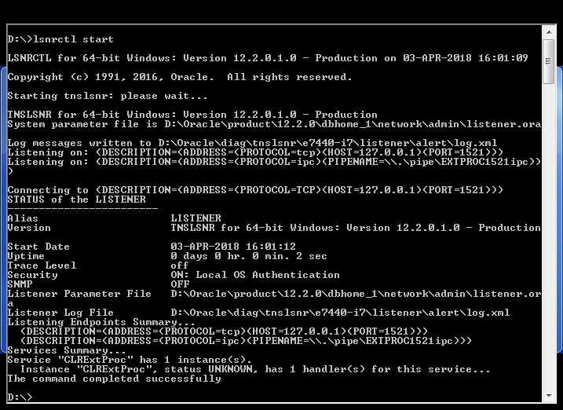

**Option 2: Configure Oracle DB Listener Service (remote Oracle DB connection)**

1. Stop the Oracle LSNRCTL service **as Administrator**:

> LSNRCTL stop

2. Copy the following files for safe keeping:

%ORACLE_HOME%\network\admin\listener.ora

%ORACLE_HOME%\network\admin\tnsnames.ora

3. When the Oracle database resides on a remote server, the listener.ora and tnsnames.ora files need to modified accordingly. It is best to seek assistance from a knowledgeable Oracle DBA, the file listings that follow have been shown to work where the remote Oracle 12c database resides on a remote Windows 10 Professional system. For this example, ORACLE_HOME is set to C:\Oracle\product\12.2.0\dbhome_1\. Your ORACLE_HOME setting may be different. Additionally you’ll need to replace your_host_name with the hostname or IP address of the remote Oracle DB server.

The %ORACLE_HOME%\network\admin\listener.ora looks as follows:

# listener.ora Network Configuration File: C:\Oracle\product\12.2.0\dbhome_1\network\admin\listener.ora

# Generated by Oracle configuration tools.

SID_LIST_LISTENER =

(SID_LIST =

(SID_DESC =

(SID_NAME = orcl)

(ORACLE_HOME = C:\Oracle\product\12.2.0\dbhome_1\network\admin\listener.ora)

)

(SID_DESC =

(SID_NAME = CLRExtProc)

(ORACLE_HOME = C:\Oracle\product\12.2.0\dbhome_1)

(PROGRAM = extproc)

(ENVS = "EXTPROC_DLLS=ONLY:C:\Oracle\product\12.2.0\dbhome_1\bin\oraclr12.dll")

)

)

DEFAULT_SERVICE_LISTENER = (ORCL)

LISTENER =

(DESCRIPTION_LIST =

(DESCRIPTION =

(ADDRESS = (PROTOCOL = TCP)(HOST = **your_host_name**)(PORT = 1521))

(ADDRESS = (PROTOCOL = IPC)(KEY = EXTPROC1521))

)

)

4. The %ORACLE_HOME%\network\admin\tnsnames.ora looks as follows and requires you to replace your_host_name with your Oracle DB’s hostname or IP address:

# tnsnames.ora Network Configuration File: C:\Oracle\product\12.2.0\dbhome_1\network\admin\tnsnames.ora

# Generated by Oracle configuration tools.

LISTENER_AMC2 =

(ADDRESS = (PROTOCOL = TCP)(HOST = your_host_name)(PORT = 1521))

ORCL =

(DESCRIPTION =

(ADDRESS = (PROTOCOL = TCP)(HOST = your_host_name)(PORT = 1521))

(CONNECT_DATA =

(SERVER = DEDICATED)

(SERVICE_NAME = orcl)

)

)

AMC2 =

(DESCRIPTION =

(ADDRESS = (PROTOCOL = TCP)(HOST = your_host_name)(PORT = 1521))

(CONNECT_DATA =

(SERVER = DEDICATED)

(SERVICE_NAME = amc2)

)

)

5. Restart the Oracle LSNRCTL service **as Administrator**:

> LSNRCTL start

**Create a JDBC Data Source (Oracle DB) in the WebLogic Server**

1. Open WebLogic Admin Console

http://*<AMC Server IP Address>:*7001/console

Username: weblogic

Password: *<Admin password>*

2. From the domain structure block to the left, go to Services and select Data Sources

3. Click "New" pull down menu, select "Generic Data Source"

This will open up a "Create a New JDBC Data Source" page:

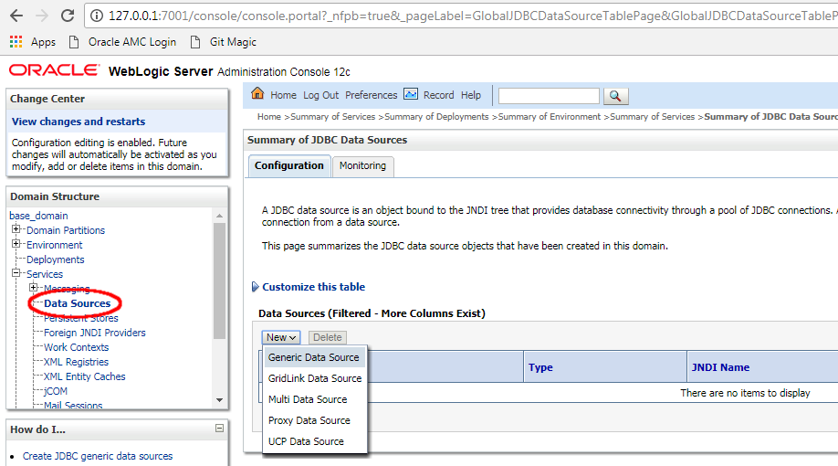

4. Set

Name: amc2 oracle

JNDI Name: amc2/db/oracle

Database Type: Oracle

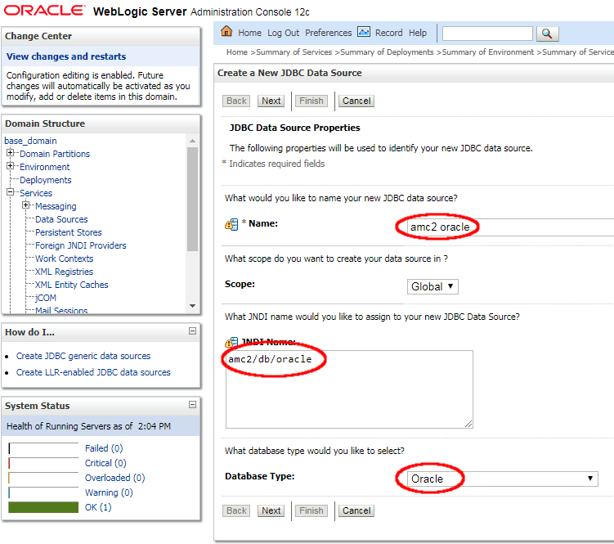

Click Next.

5. Select *\*Oracle’s Driver (Thin) for instance connections; Versions: Any* as the Database Driver. Note: this is not the default option. You will need to select it from the Database Driver pull down menu.

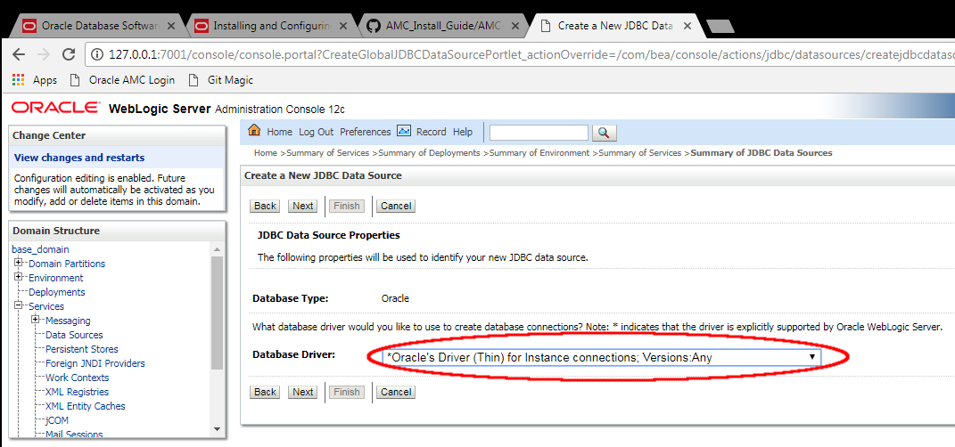

Click Next.

6. Transactions section:

Uncheck "Supports Global Transactions" (This is checked by default)

Check "One-Phase Commit" (should be checked by default)

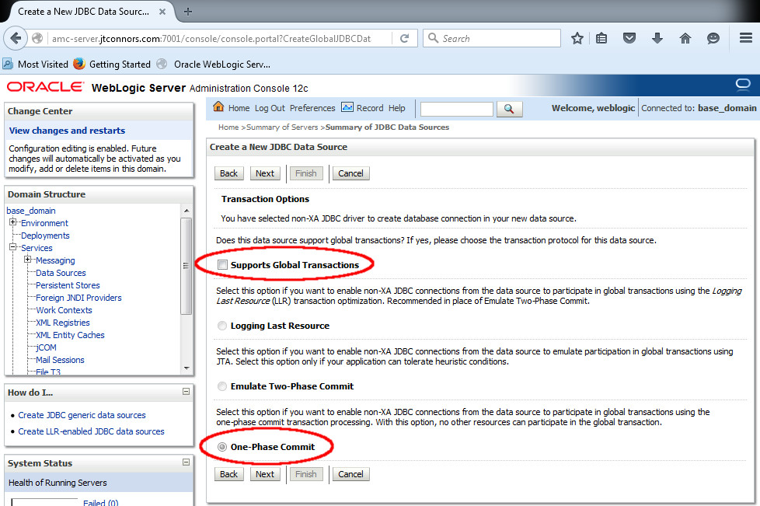

Click "Next"

7. Connection Properties, set:

Database Name: orcl

Host Name*: <AMC Server Hostname – likely not 127.0.0.1 >*

Port: 1521 *<The port number configured in the* listeners.ora *file a few steps ago>*

Database User Name: amc2

Password: *<password created when Oracle DB was installed>*

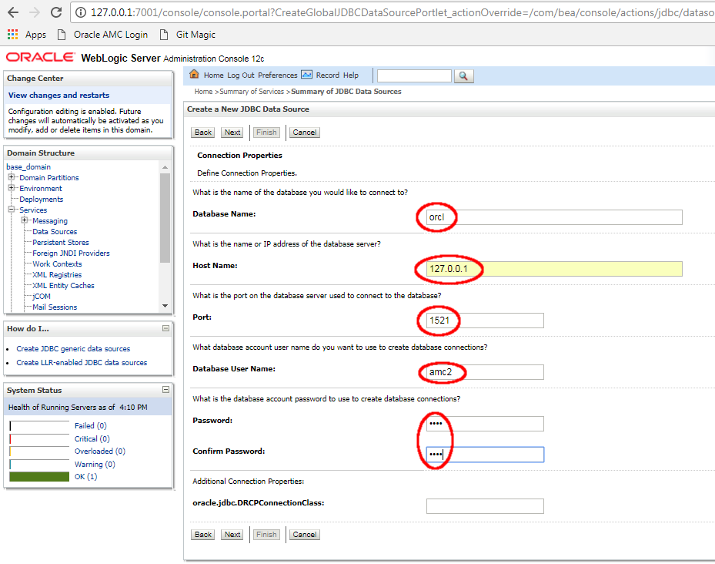

Click "Next"

8. In the Properties text box, append the following lines:

useUnicode=yes

characterEncoding=UTF-8

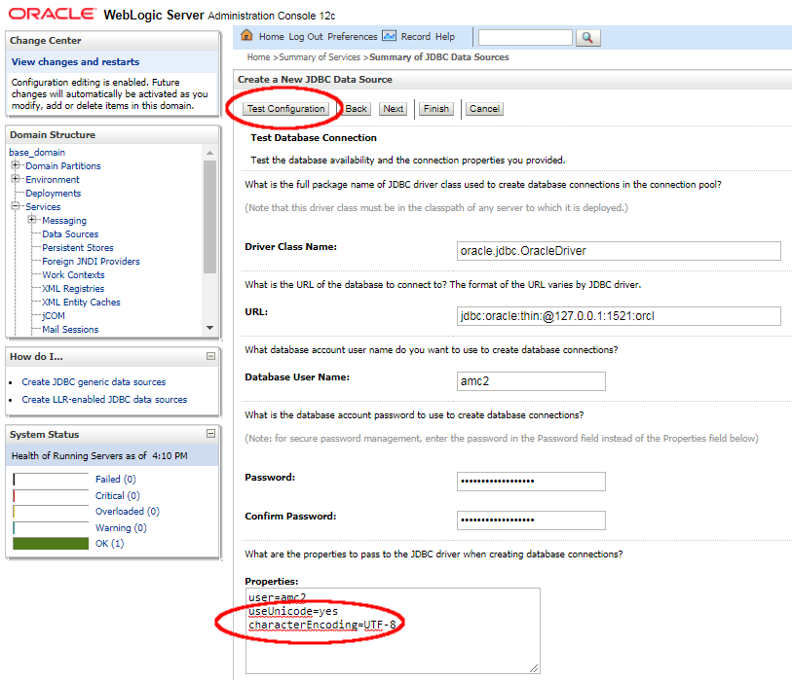

9. Click "Test Configuration"

10. Connection Test should come back as having succeeded.

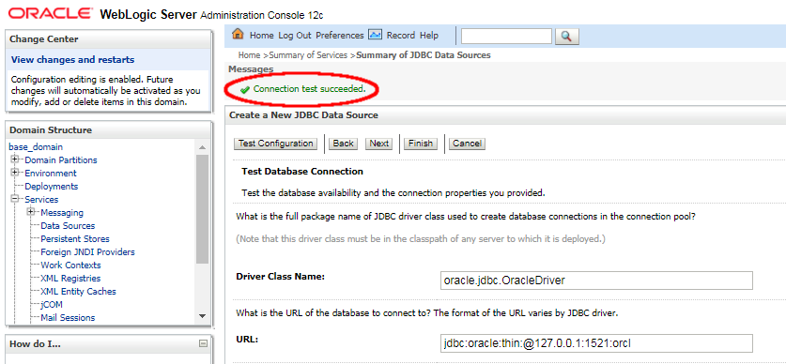

Click Next

11. The following dialog, enabling you to associate the recently created "amc2 mysql" data source with a server instance, should be displayed. Select the AMC-Server checkbox.

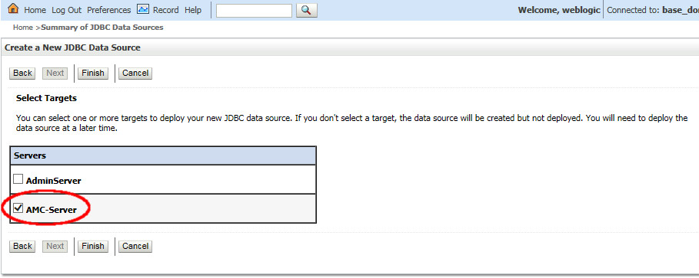

Click Finish.

12. Increase the default connection pool size for the WebLogic Server. It is recommended that the default connection pool size be set to at least 50, and under heavy loads, even higher.

Select the *amc2 oracle* data source from the JDBC Data Sources list:

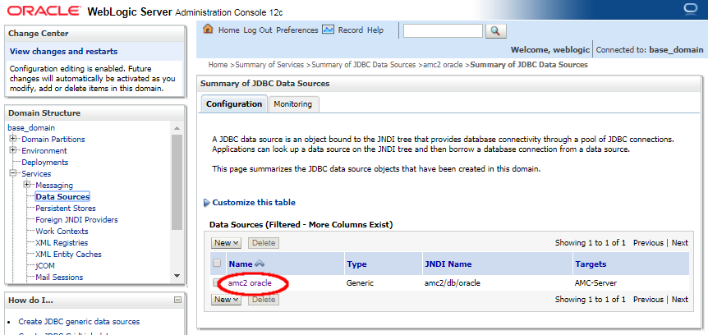

Next, select the Connection Pool tab:

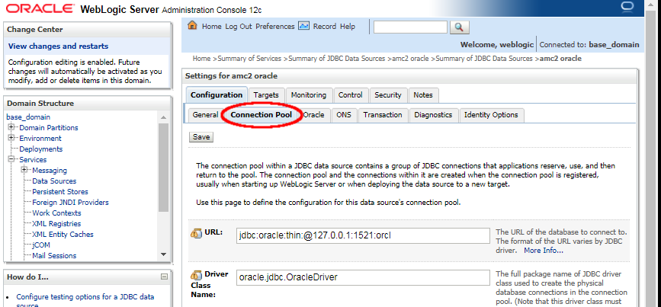

On this page, locate the *Maximum Capacity* textbox near the bottom and set it to a value of 50 (or possibly larger):

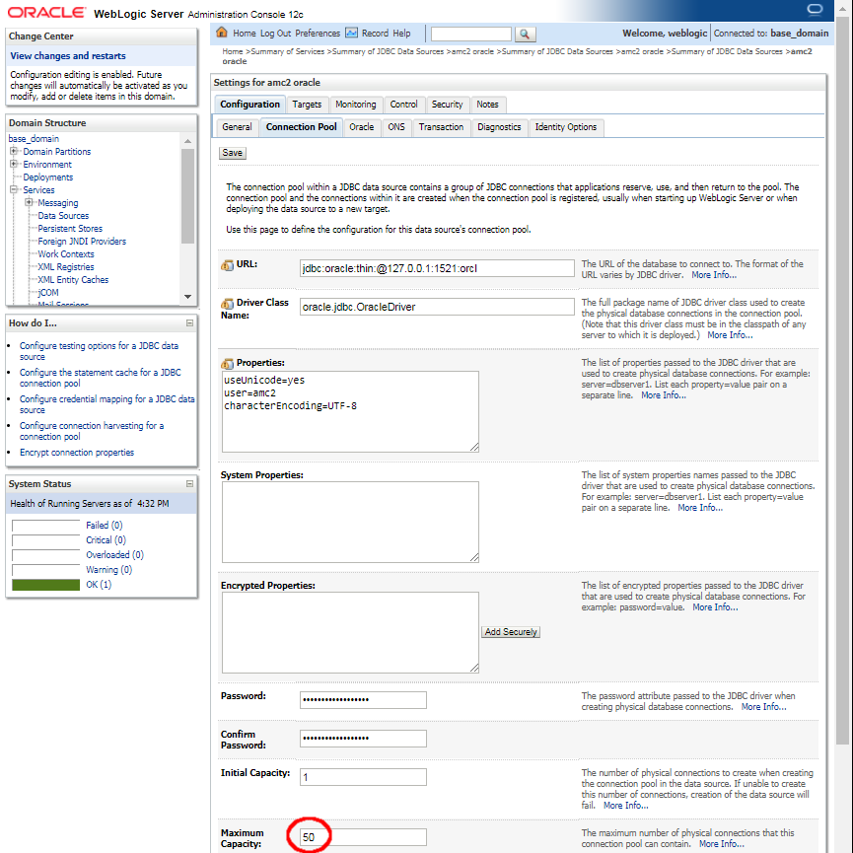

Click Save button**Deploy the Java AMC Application**

Java AMC is a Java EE application that has to be deployed into the WebLogic Server. Prior to doing so, the JAX-RS library must be deployed as a prerequisite first.

From the domain structure block to the left, go to Environment and select Deployments.

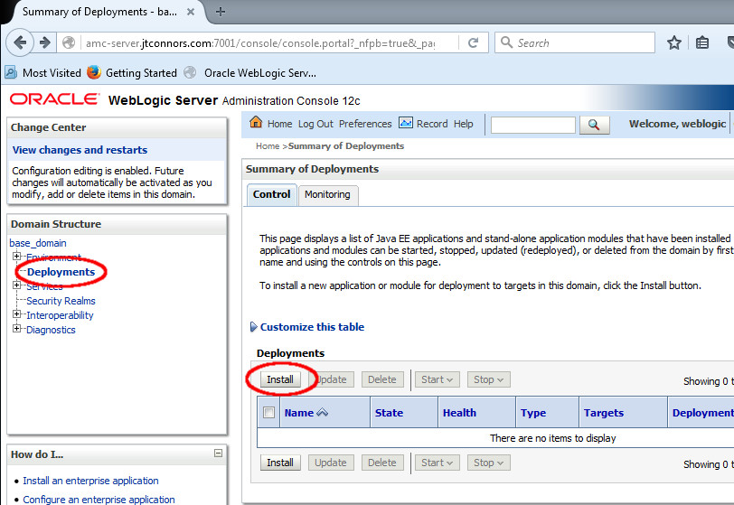

Click "Install".

Within the Install Application Assistant screen, navigate to C:\Oracle\Middleware\Oracle_Home\wlserver\common\deployable-libraries and select the jax-rs-2.0.war file.

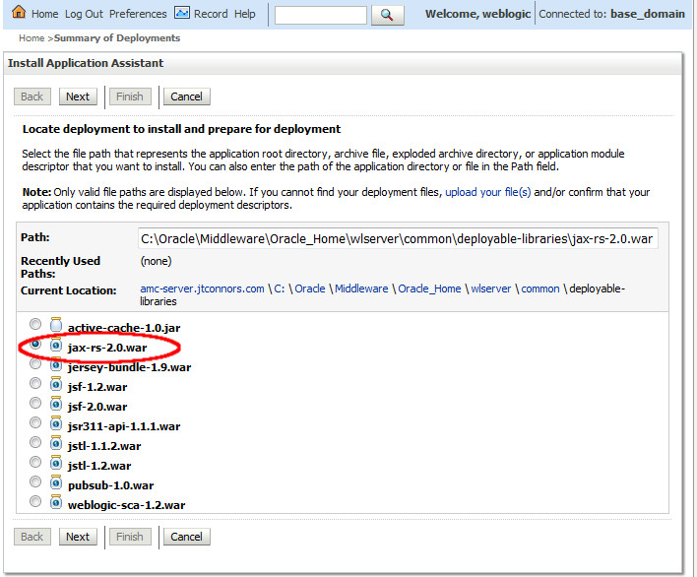

Click Next.

It should be selected already, make sure "Install this deployment as a library" is selected.

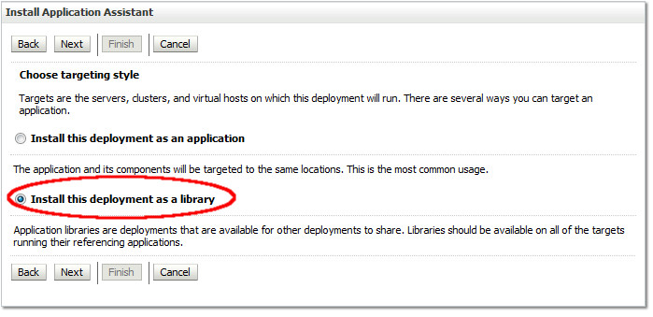

Click Next. For a target, select the AMC-Server checkbox.

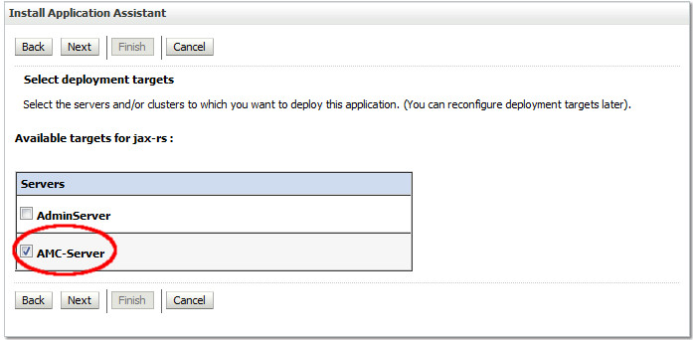

Click Next.

Leave all of the optional settings as is for the page that follows.

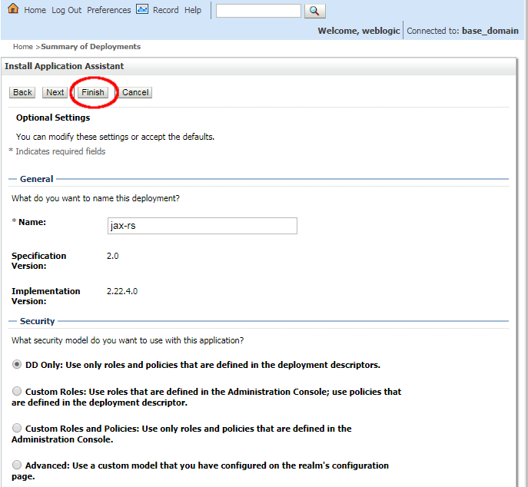

Click Finish.

Install the Java AMC application. From the Deployments page, click on Install (notice jax-rs has been installed as a library). 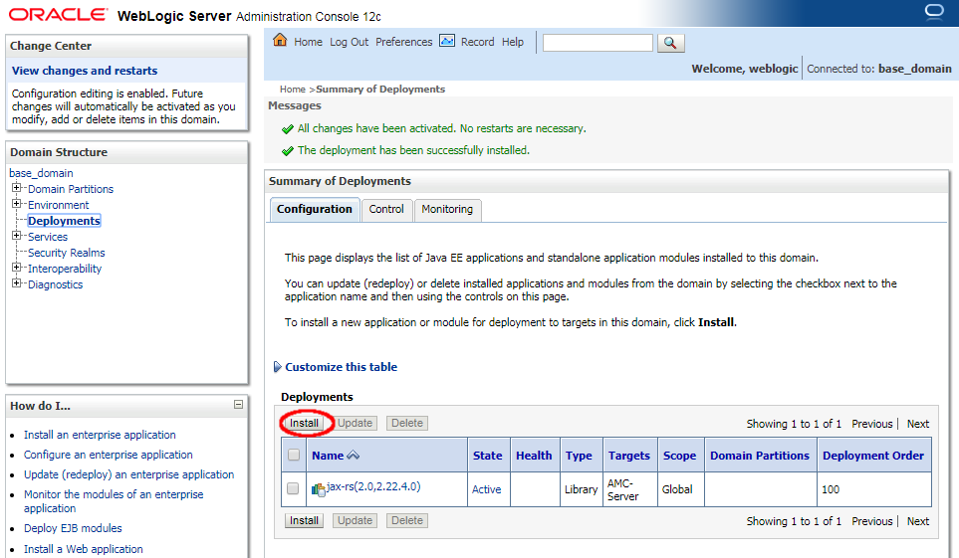

Locate where the JavaAMC-2_12.ear file was downloaded in your file system and select the file. Note: Java AMC 2.12 may have been downloaded from the Oracle website as JavaAMC-2_12.**zip**.Rename this file to JavaAMC-2_12.**ear** and proceed.

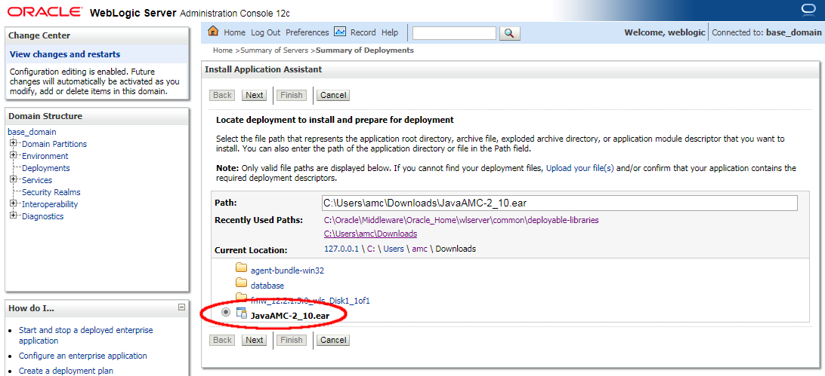

Click Next.

It should be selected already, make sure "Install this deployment as an application" is selected.

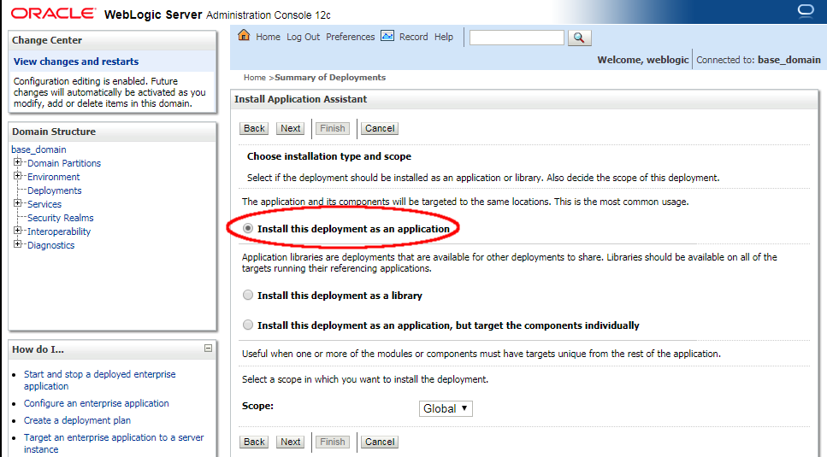

Click Next. For a target, select the AMC-Server checkbox.

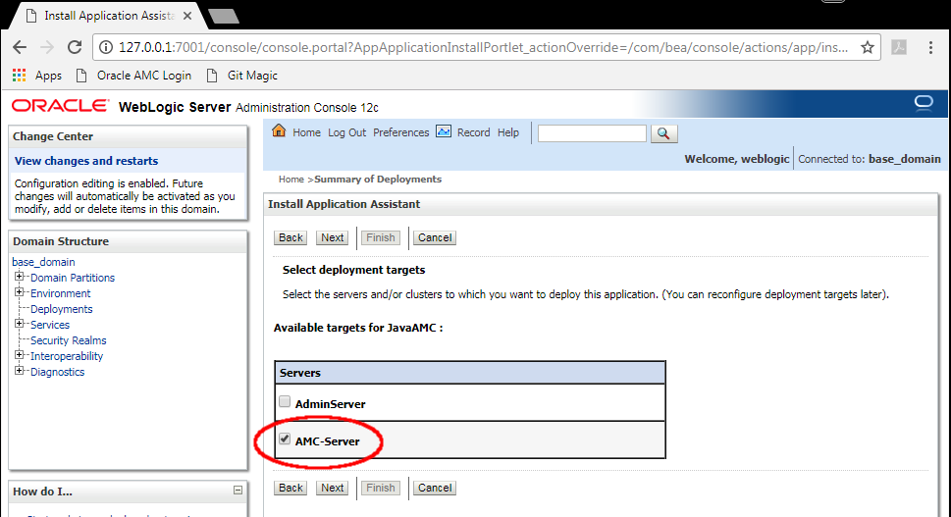

Click Next.

Leave all of the optional settings as is for the page that follows.

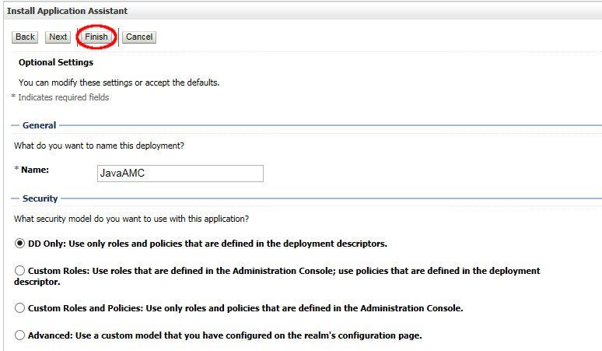

Click Finish.

Appendix

**Revision History**

**Version 2.12, Rev 0: AMC-InstallGuide-Win-OracleDB: 16-Oct-2018**

* Latest Java Update is 8u191
* Replace AMC 2.11 with AMC 2.12 deployment

**Version 2.11, Rev 0: AMC-InstallGuide-Win-OracleDB: 23-Jul-2018**

* Latest Java Update is 8u181
* Replace AMC 2.10 with AMC 2.11 deployment

**Version 2.10, Rev 1: AMC-InstallGuide-Win-OracleDB: 30-Apr-2018**

* Add section assisting with remote Oracle DB configurations

**Version 2.10, Rev 0: AMC-InstallGuide-Win-OracleDB: 20-Apr-2018**

* Replace MySQL install with install of Oracle DB 12c Release 2 (12.2.1.2.0)
* Update Install to WebLogic 12.2.1.3
* Latest Java Update is 8u171/172, recommend install with 8u151/8u152 to avoid install bug
* Replace *Configure WebLogic Server with MySQL* with Oracle DB
* Replace AMC 2.9 with AMC 2.10 deployment

**Version 2.9, Rev 0: AMC-InstallGuide-Win-MySQL: 28-Mar-2018**

* First version to be brought into GIT repository
* Update Install to Java AMC 2.9
* Update Install to WebLogic 12.2.1.3
* Reworked WebLogic 12.2.1.3 Install screenshots
* Reworked WebLogic Configuration Manager screenshots for version 12.2.1.3
* Reworked *Install Windows Services* section
* Reworked *Deploy The Java AMC Application* section screenshots
* Leave MySQL install alone, however mention latest supported MySQL version is now 5.7.21
* Comment on bug and workaround concerning WebLogic 12.2.1.3 installation with jdk8u161/162
* Added footer with page number and revision

**Rev 0: AMC_2_7-InstallGuide-Win-MySQL: 24-Jul_2017**

* Update Install to Java AMC 2.7
* Update latest Java 8 baseline to JDK 8 update 141
* Reference to latest MySQL (5.7.19), but still show 5.7.13 example install
* Update MySQL Zip archive install section to use MySQL 5.7.19
* Update install to WebLogic 12.2.1.2
* Added Install Windows Services Section (automated by scripts)
* Move manual Install Windows Services Section to Appendix
* Manual Windows Service Install: Added dependency to NodeManager in AMC-Server service

**Rev 0: AMC_2_6-InstallGuide: 27-Jan_2017**

* Support for AMC 2.6
* Update latest Java 8 baseline to JDK 8 update 121
* Added part to increase JDBC connection pool maximum

**Rev 0: AMC_2_5-InstallGuide: 28-Oct_2016**

* Support for AMC 2.5
* Update latest Java 8 baseline to JDK 8 update 111
* Update reference to latest MySQL 5.7.16, but kept 5.7.13 install screenshots
* Changes to manual MySQL installation, add basedir and datadir to my.ini file.
* Update reference to latest WebLogic 12.2.1.2, but kept 12.2.1 install screenshots

**Rev 0: AMC_2_4-InstallGuide: 26-July_2016**

* Support for AMC 2.4
* Change to MySQL 5.7.x (5.7.13)

### Update latest Java 8 baseline to JDK 8 update 101

### Change to WebLogic 12.2

### DRS tool gone, eliminate DRS tool self-signing documentation.

### Rev. 4: 29-Apr-2016

### Added appendix to install MySQL 5.6.30 manually

### Reorder sections: place *Additional WebLogic Configuration...* before *Install Windows Services...*

### In *Install Windows Services...* section, increase AMC-Server heap size to -Xmx2048m

### In *Install an Identity Certificate...* section, start WebLogic server if not already started

### Updated the *Deploy Java AMC Application* section to Java AMC 2.3

### Update latest Java 8 baseline to JDK 8 update 91

### Rev. 5: 19-May-2016

### In *Install Windows Services...* section, increase AMC-Server heap size to –Xmx4096m

### No longer need to modify CommEnv.cmd to increase AMC-Server heap to -Xmx4906m, just set USER_MEM_ARGS in the scripts/installAMCServerSvc.cmd file

### fix typo in scripts/installWebLogicSvc.cmd

### Updated Windows Services scripts, added uninstall service scripts to this section